***Java 11 in 7 Days***

Exploring Java:

* High-level, third-generation programming language
* Unusual in that it is both compile and interpreted
* Very case sensitive
* Does not accept spaces when naming classes, methods, or variables
* An object-based language – was designed so that programmers could design their own data types
* Known as a “compile once, run anywhere” language

How to Compile and Run a Java Program

* As we can see from the diagram, it is a two step process
* Write source code, save it as a file, compile it, and then run the compiled file through the interpreter

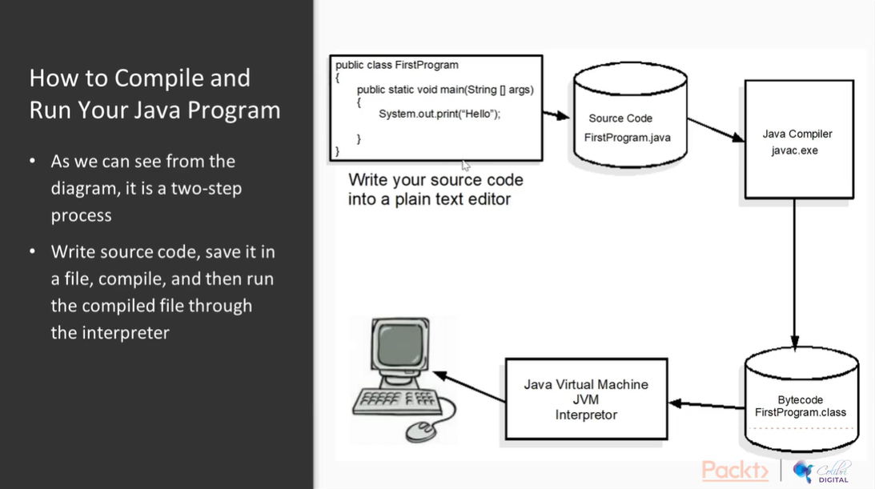

What is a compiler?

* It parses the source code to see whether there are any syntax errors
* If there are syntax errors, it will attempt to show you where those errors are in the source code
* It produces intermediate binary code called bytecode

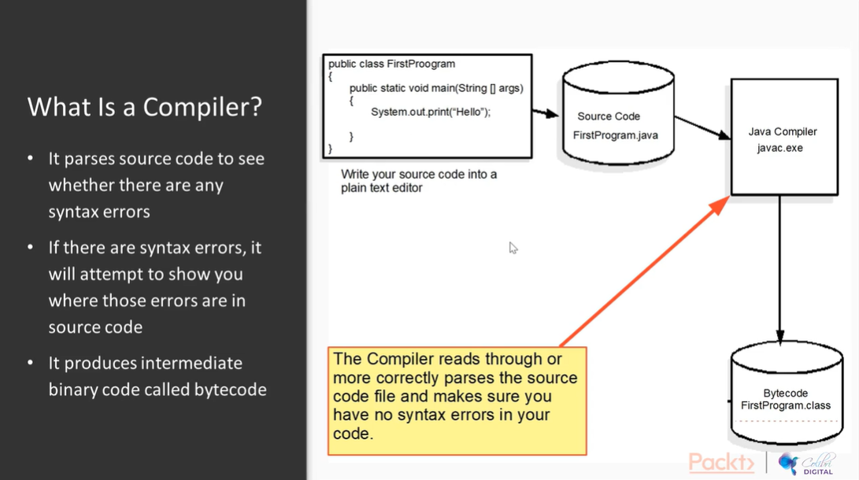

What is an Interpreter?

* It will interpret the intermediate bytecode for a particular CPU as long as that computer has the appropriate Java runtime(interpreter/JVM) installed

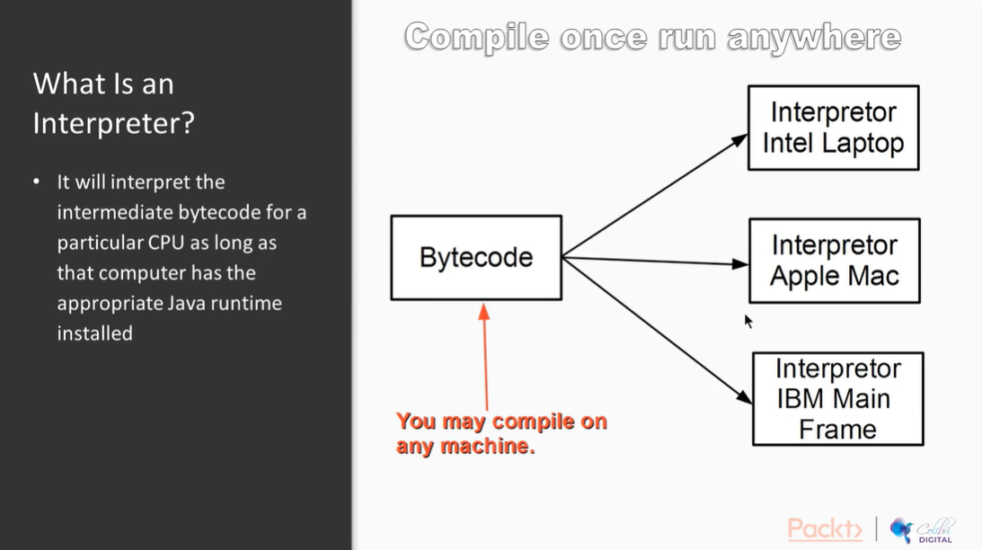

Exploring Some Rules in Java

* May use any alphanumeric characters plus the underscore and dollar character to name classes, methods, and variables
* All forms of braces, parentheses, etc. are matched – that is for every opening brace/parenthesis, there must be a corresponding closing one
* A name may not begin with a number
* Every Java application must have one public static void main(String [] args) method
* The name of the file in which you save your source code must have an extension name of java. Example: FirstProgram.java
* Every Java program must be declared within a class

Exploring Conventions in Java

* A class name must always begin with a capital letter
* All methods and variable names begin with a small letter except for a final variable which is named using all capital letters
* Even though you are allowed to use the dollar sign in naming classes, methods, and variables, don’t do it

The basic structure of a Java Program

* The name of the program is “FirstProgram”
* Saved in a file called FirstProgram.java
* The class is defined between two red curly braces
* The ‘starting point’ method is defined between the two green curly braces
* All Java programs need a starting point

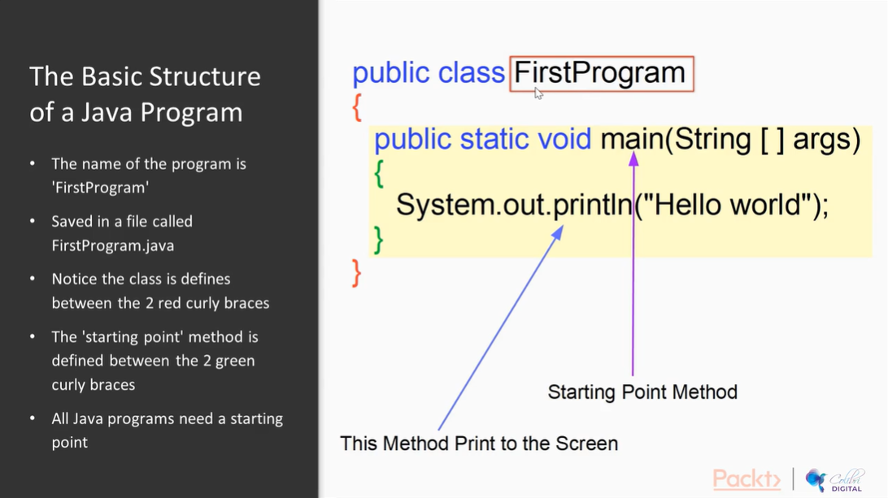

What is a String Class in Java?

* The String class is a complex data type
* The Java Development Kit has a number of Libraries of code that we may use
* The standard library in Java is known as java.lang
* Within java.lang we find the String class

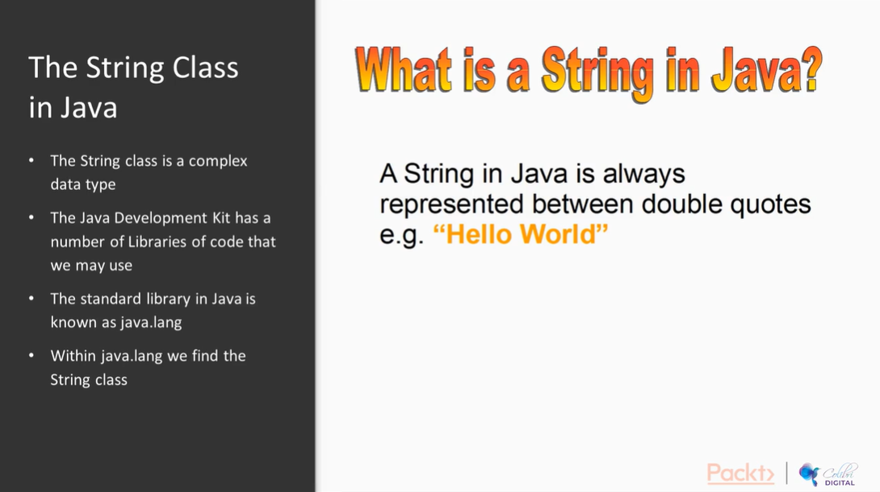

Comments in Java

* Comments in Java are used to help understand what a developer has written in source code
* Comments are ignored by the compiler
* Java has 3 flavors of comments (single line, multi-line, java doc)

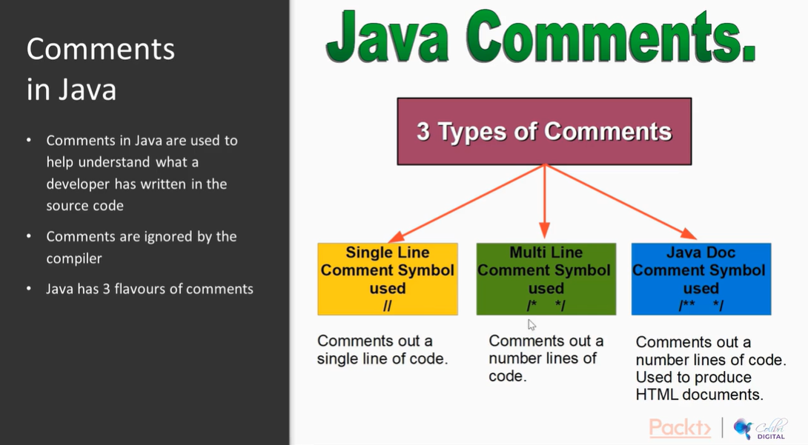

What is a Variable When Thinking as a Computer Programmer?

* In Java, a variable is a named memory location
* You may assign values to it
* You may assign new values to the memory location at any time – hence the term “variable”
* Once you assign a new value to a variable, the old value is lost forever

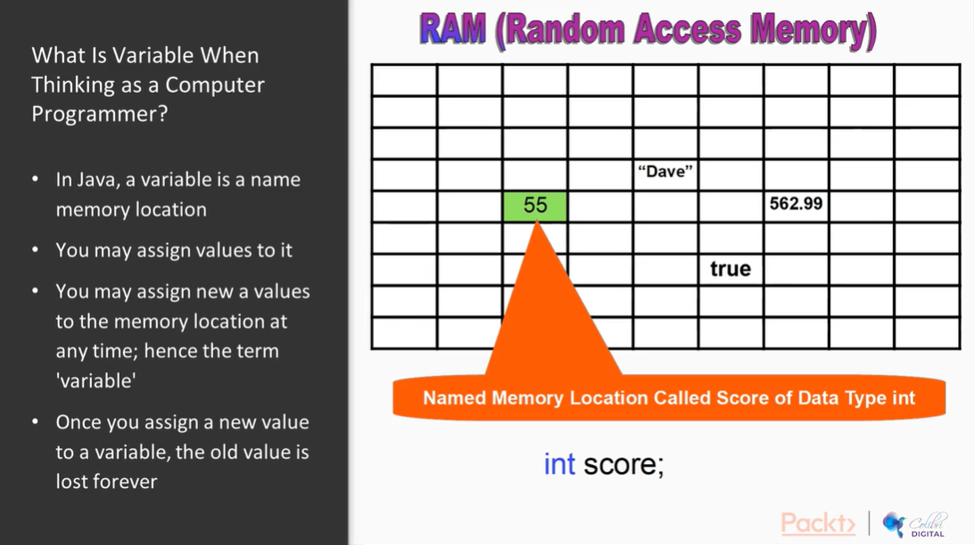

In Java, there are 2 categories of data types:

* Primitive Data Types (built-in Data Types that do not have to be defined and can be used as is)
* Complex or Programmer Defined Data Types

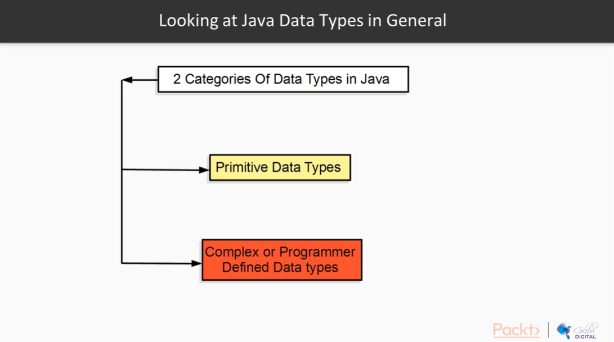

There are Four Categories of Primitive Data Types

* Real Numbers (float, double)
* Integer Numbers (byte, short, int, long)
* Booleans
* Characters (char)

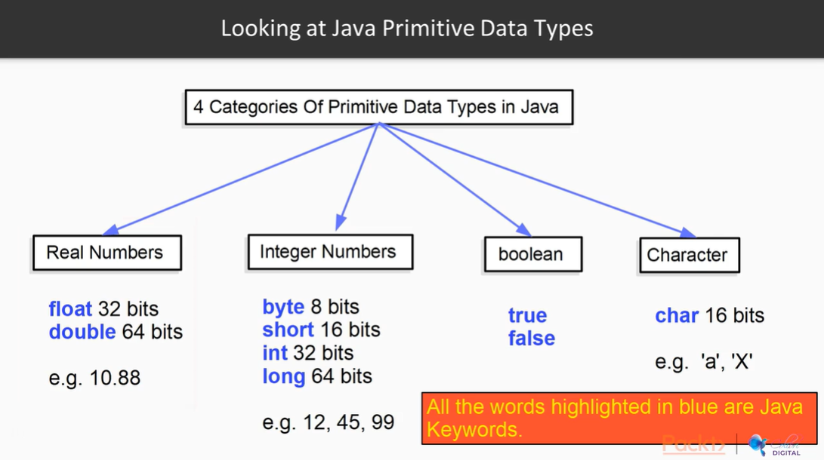

What is a Java Keyword?

* It is a word that the compiler understands. You may not use keywords to name anything.

Complex Data Types are data types that have been designed by programmers and are not build into the JVM. Instead, they are stored in Libraries. Example: String.class -> java.lang library

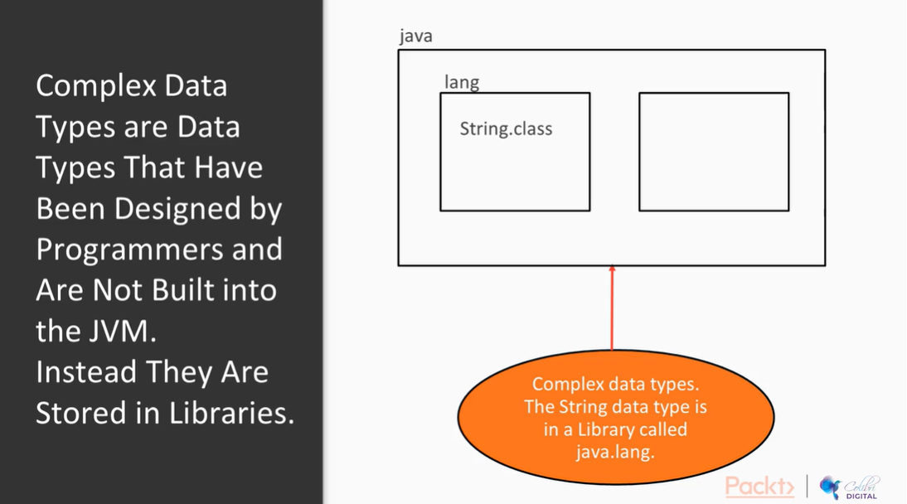

Java is a ***STRONGLY TYPED*** language, meaning that you must tell the JVM what type of data it will be storing in memory.

**Declaration**: telling the JVM to create a memory location called salary having a data type of type double

double salary;

**Initialization**: telling the JVM to assign a value of 12400.99 to the named memory location called salary

salary = 12400.99;

Reassignment: assigning a new value of 3200.55 to the memory location named salary

salary = 3200.55;

How to declare variables – variables usually always begin with a lowercase letter and we always use camel case. Examples below:

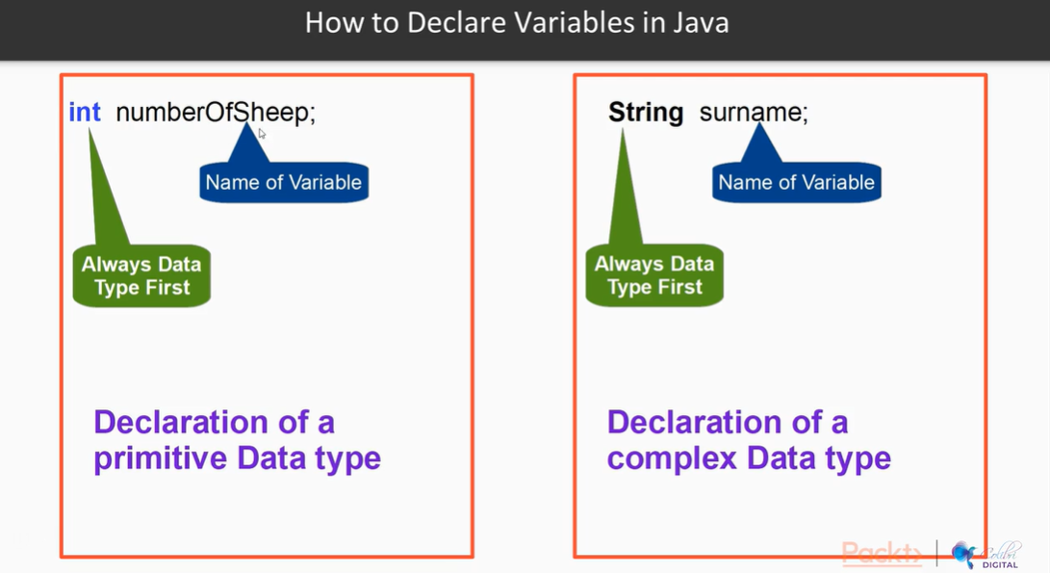

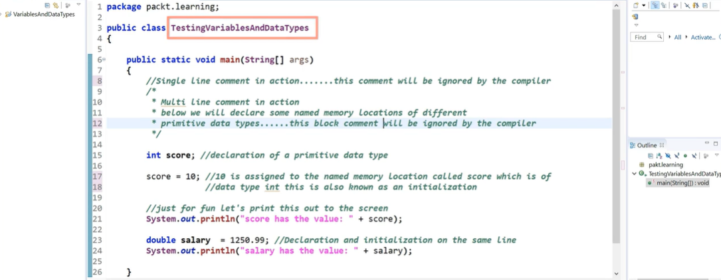

Variables can be declared and initialized all in one line:

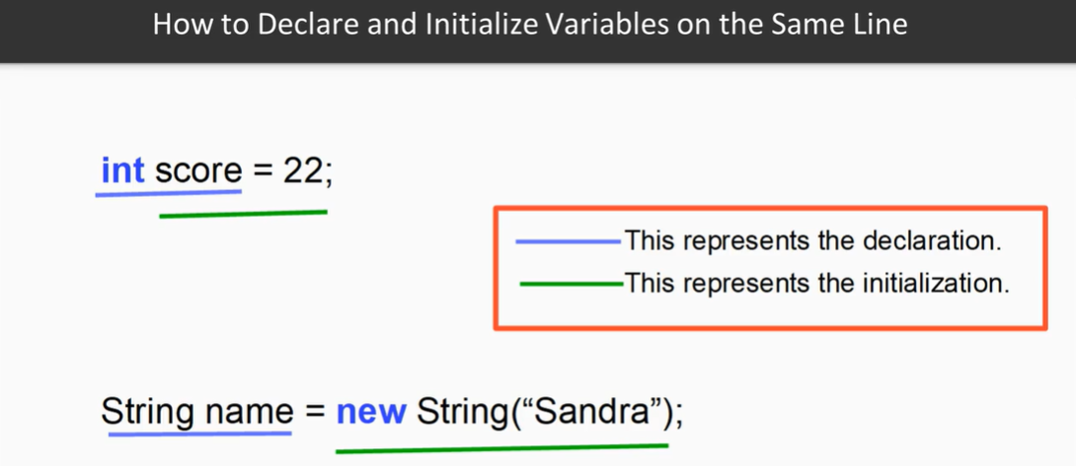

Java also allows us to declare multiple variables in different memory locations in the same line:

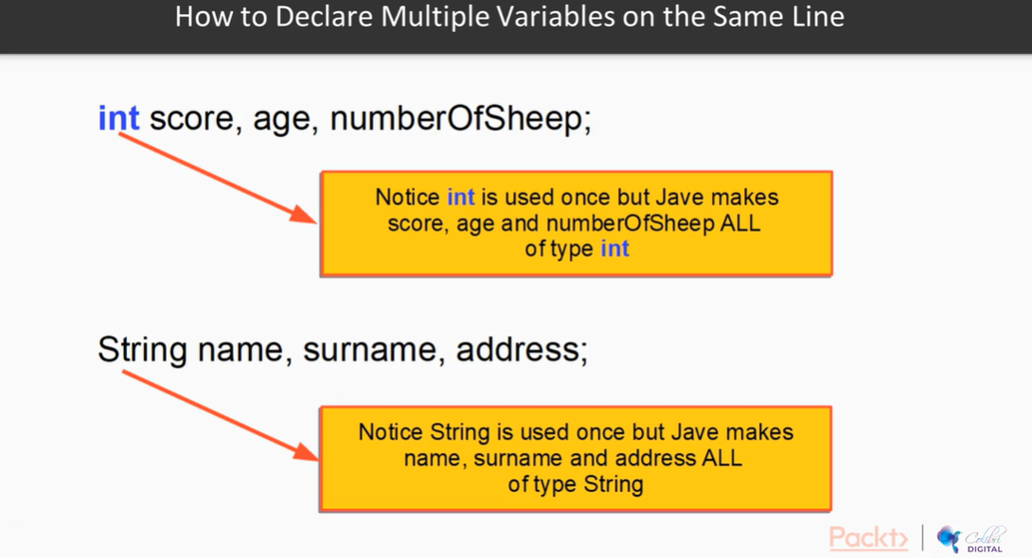

You can also declare and initialize multiple variables in different memory locations on the same line:

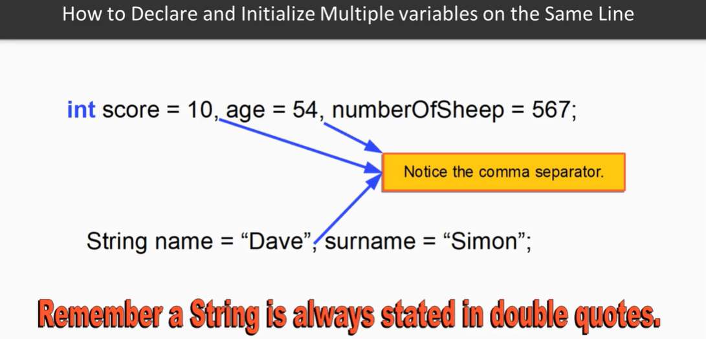

A new feature in Java since version 10 is being able to declare variables using the “var” keyword, where the JVM will look at the value of the variable, and assign the data type for you.

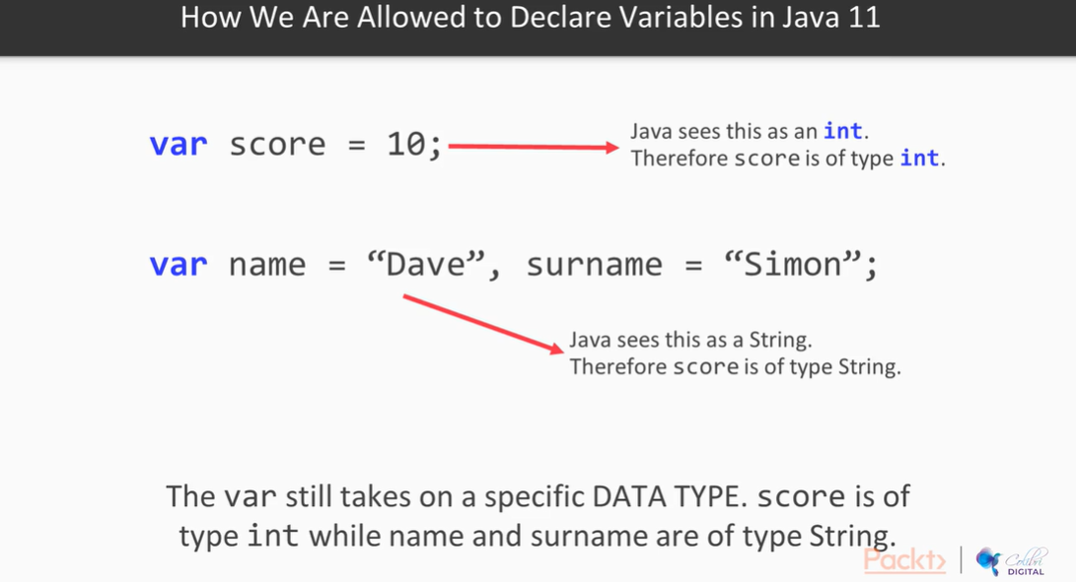

What is a Java Operator?

* An operator in Java is anything that allows you to perform some operation and/or manipulation of the data within your program.

Different types of Operators:

* Arithmetic Operators
* Relational Operators (always equate to a Boolean)
* Logical Operators (allow combination tests)
* Bitwise Operators

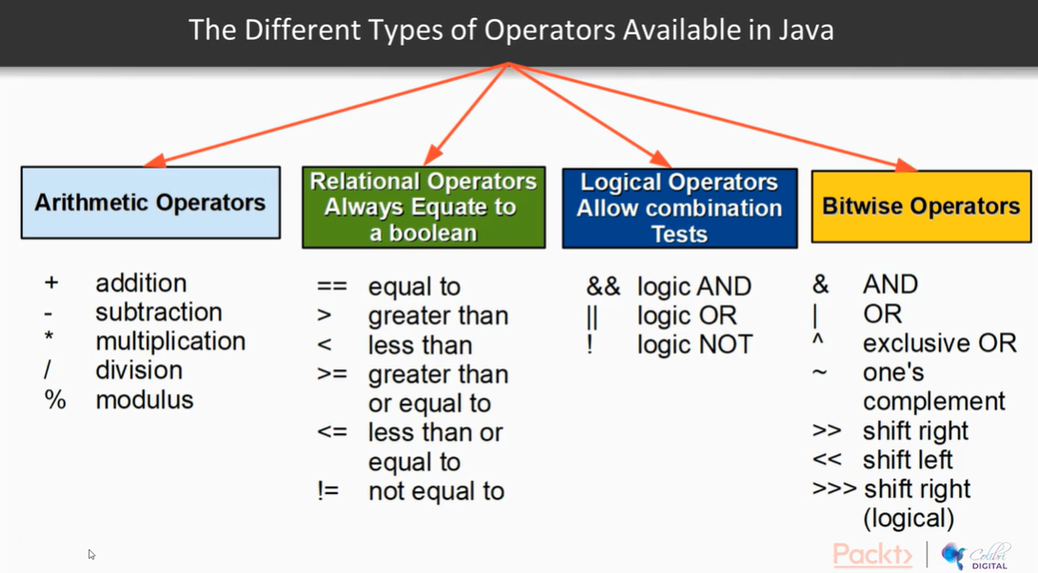

The assignment operator is a single “equal” sign. It’s referred to as “write to” or “assign”

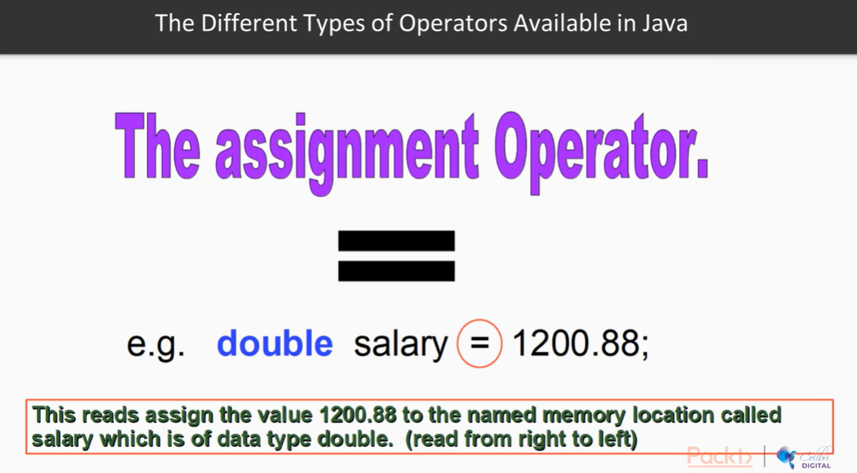

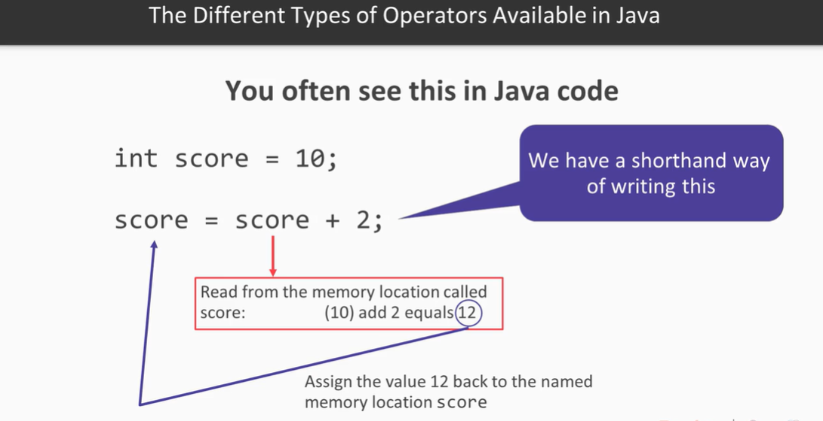

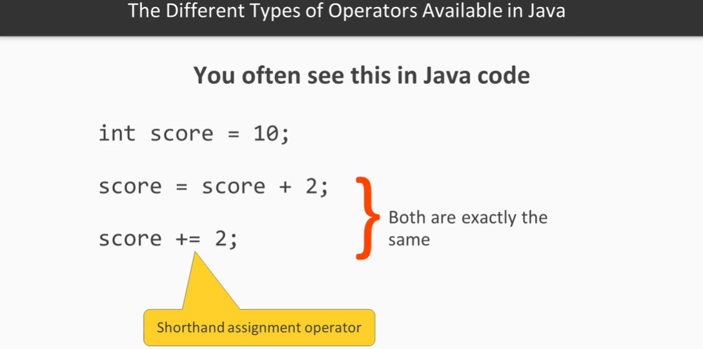

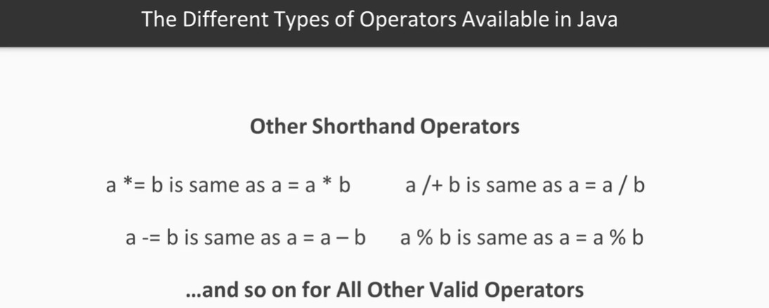

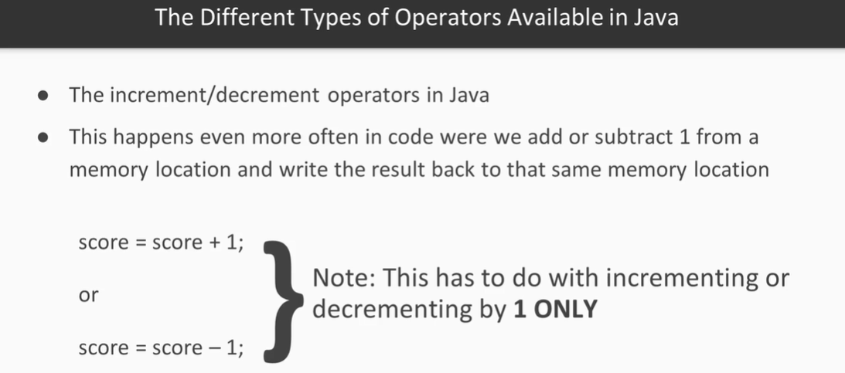

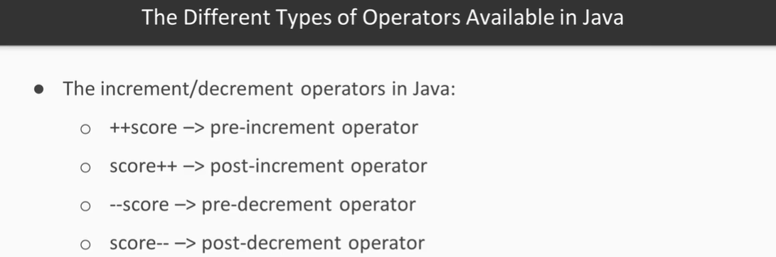

Your First Java Program

* Open up Eclipse
* Create a new Java project
* Create a source code file called FirstPGM.java
* Type some basic code
* Save the file
* Compile the file
* Run the program

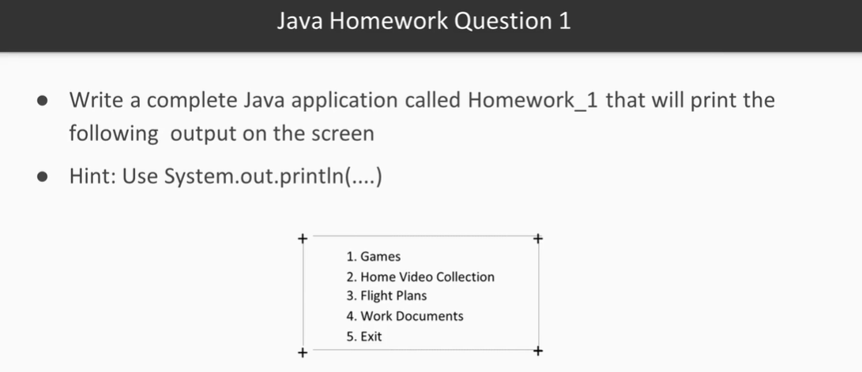

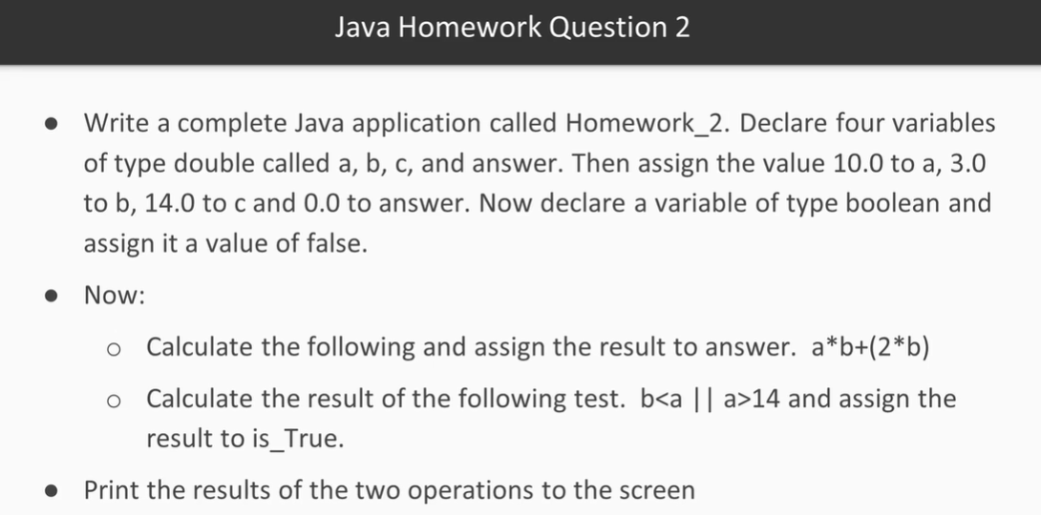

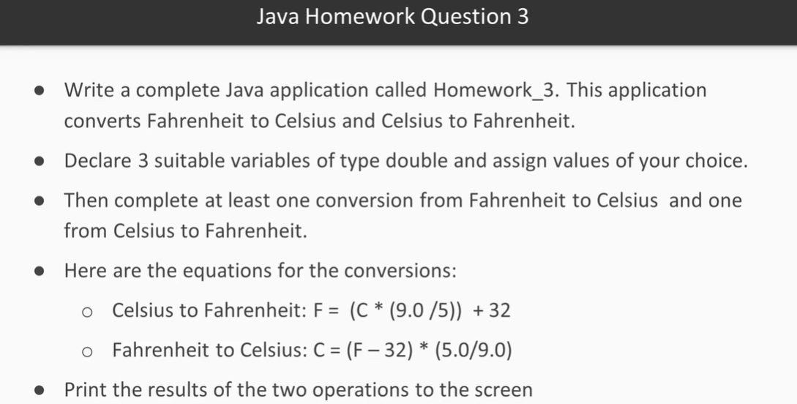

In this video, we will demonstrate what the conditional operators are and how to use them. It will introduce you to the if and if/else keywords plus show you in code how to use these 2 constructs.

* Write the demonstration code into your project
* Check if the test executes properly
* Experiment by changing the test condition

There are 3 types of conditional statements in Java:

* If/if-else
* Switch
* Ternary Operator

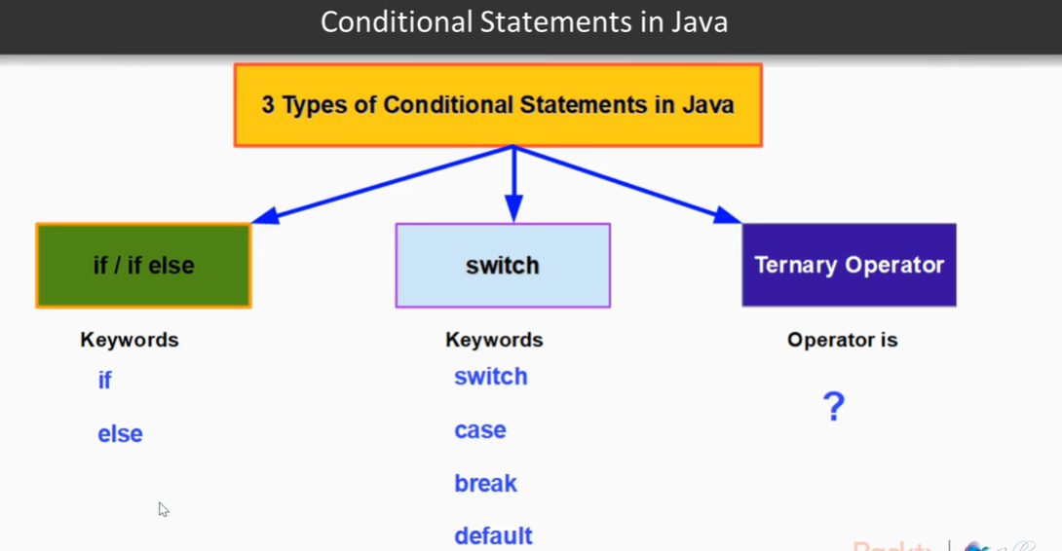

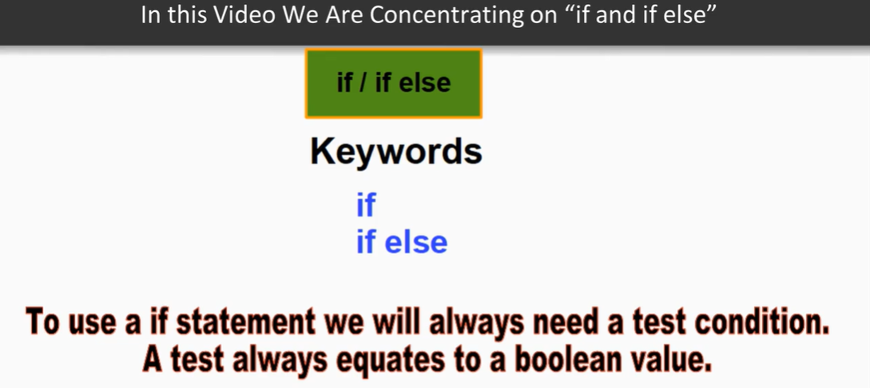

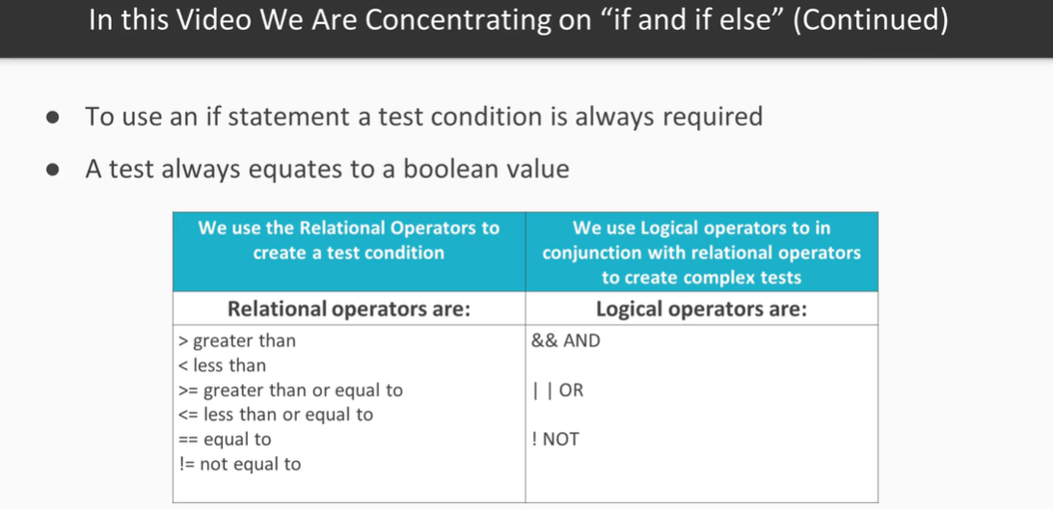

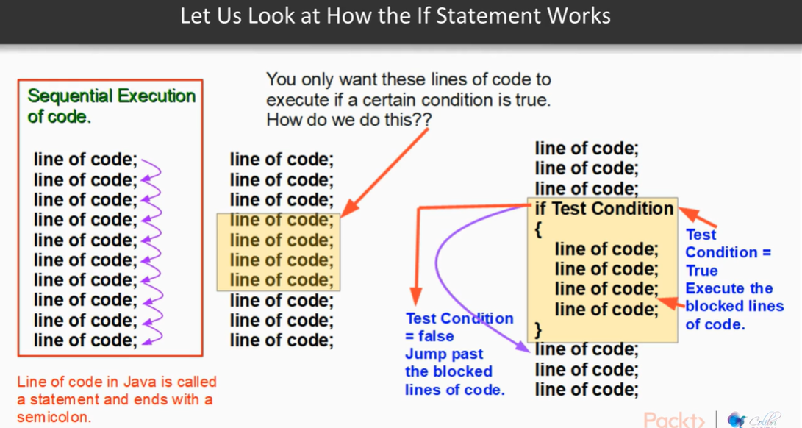

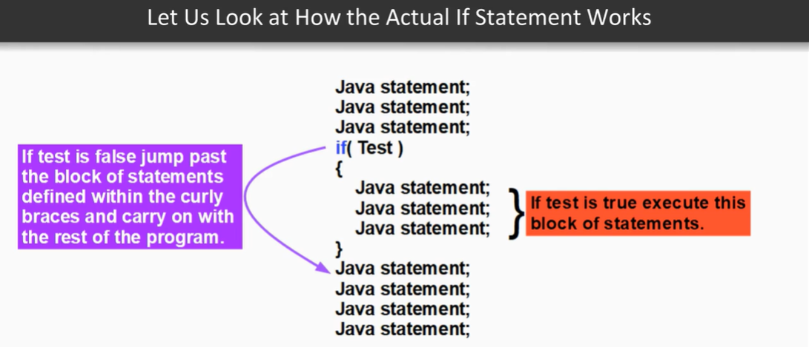

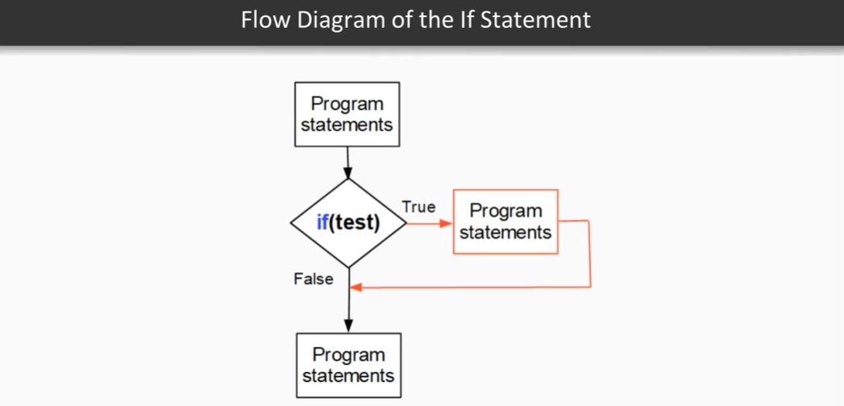

What is the Switch statement in Java?

* A switch statement allows a variable of type byte, short, int, char, string, or enum to be tested for equality against a list of constant values
* Each constant value is called a case, and the variable being switched on is checked against each case
* Switch statement keywords: switch, case, break, default
* The variables in a Switch statement can *only be* byte, short, char, string, and enum
* You can have any number of case statements within a switch
* Each case is followed by the constant value to be compared against and then a colon separating the java statements that follow
* The value for a case must be the same data type as the variable in the switch, and it must be a constant or a literal
* When the variable is equal to a case, the statements following that case will execute until a break or return statement is reached
* When a break statement is reached, the switch terminates, and the flow of control jumps to the next line following the switch statement’s closing brace
* Not every case in a switch needs a break
* If no break appears, the flow of control will fall through to subsequent cases until a break is reached
* A switch statement can have an optional default case, which must appear at the end of the switch
* The default case can be used for performing a task when none of the cases is true
* No break is needed in the default case

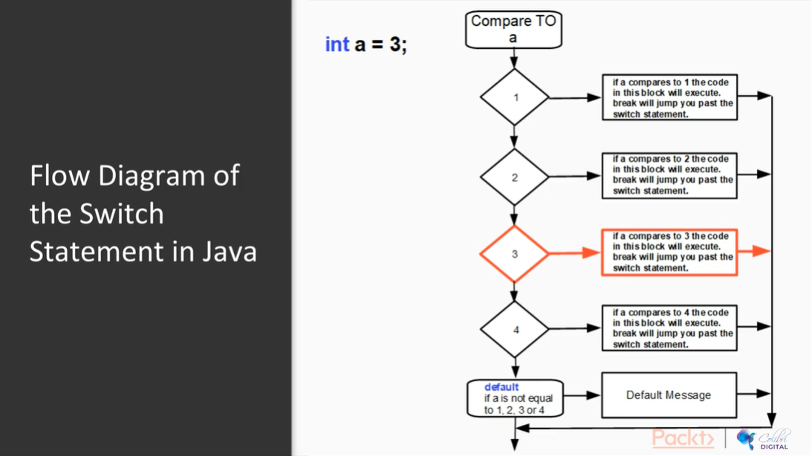

Logical Operators:

* &&, ||, and !
* Logical operators are used to combine tests

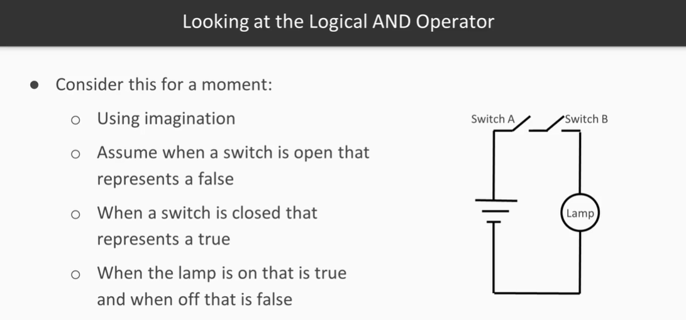

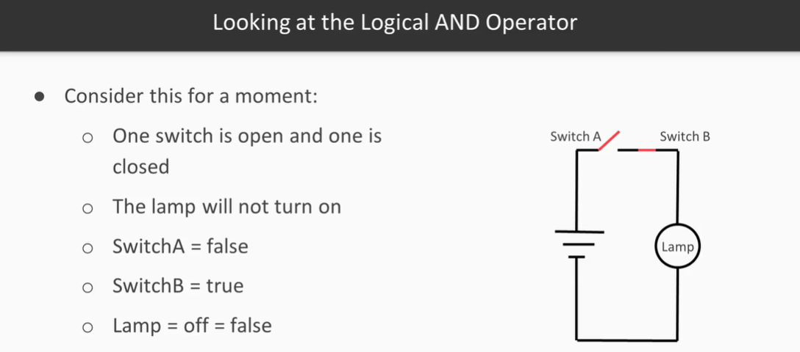

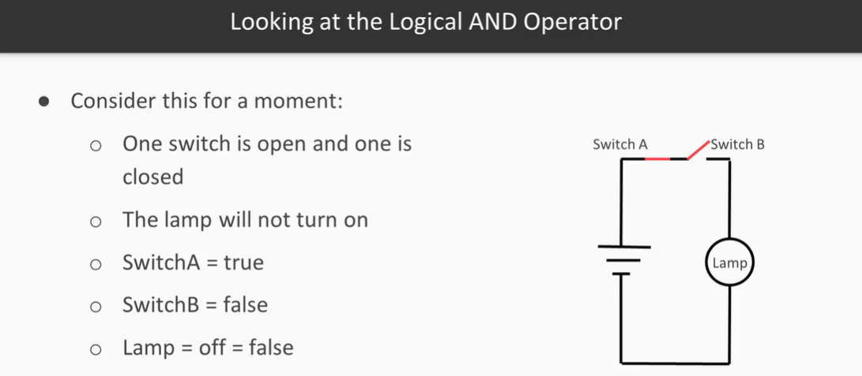

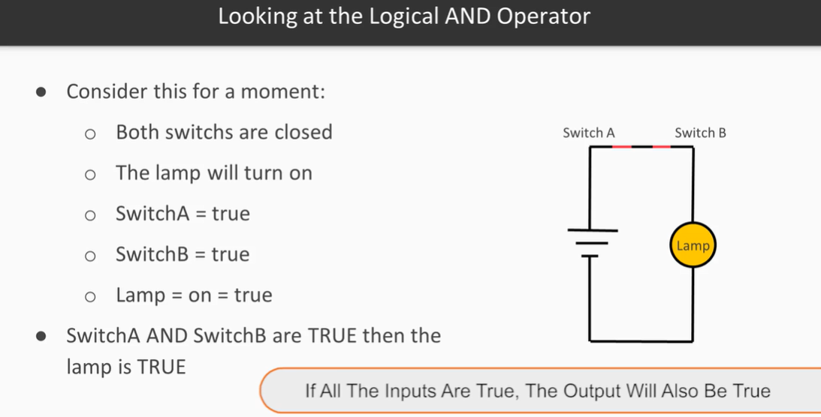

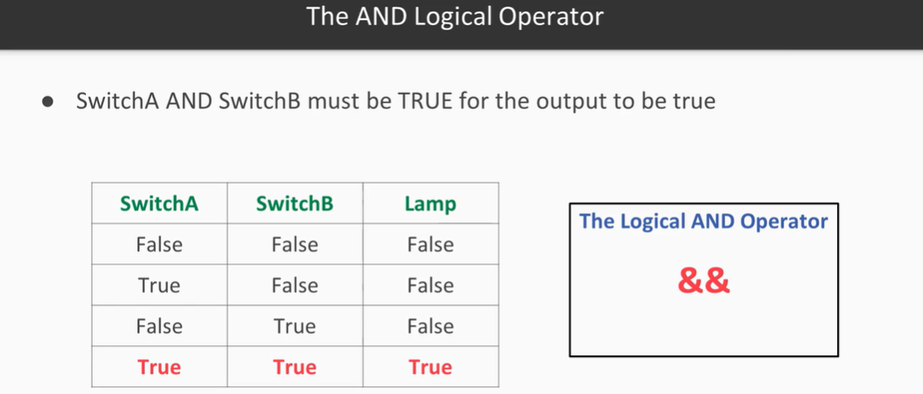

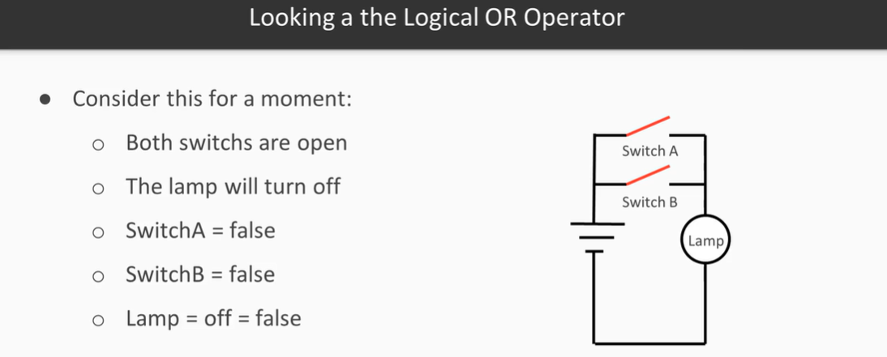

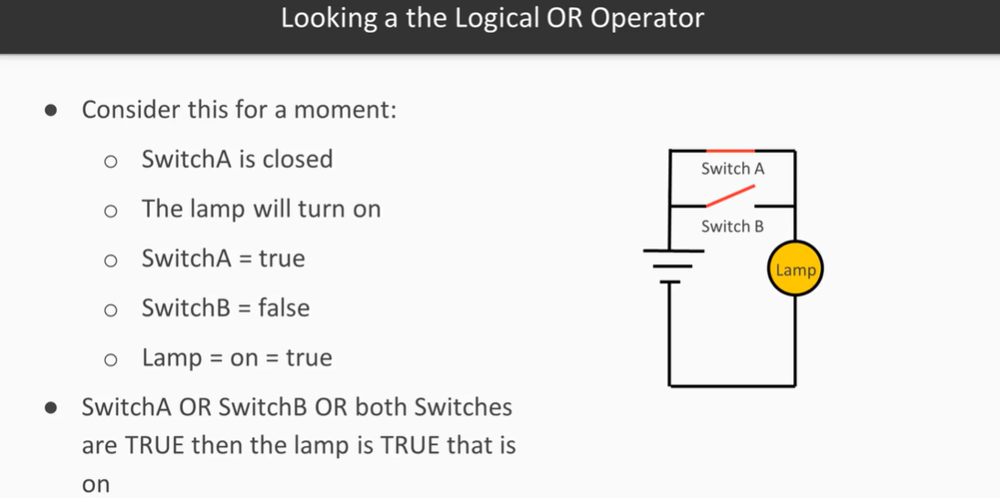

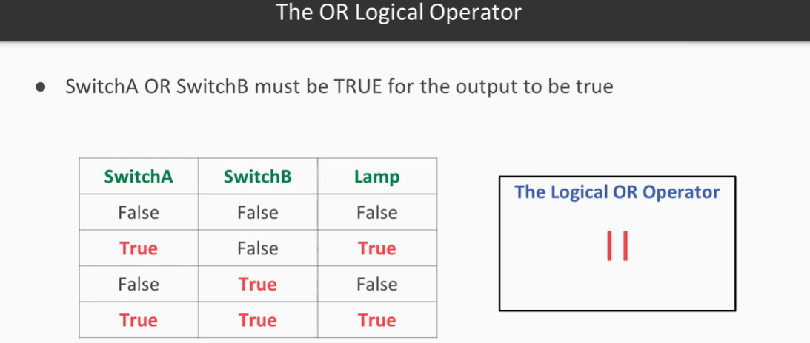

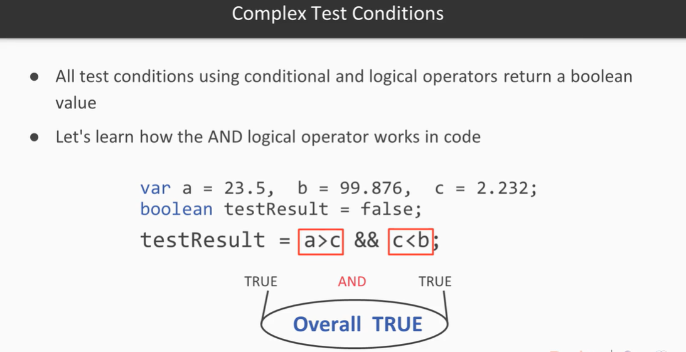

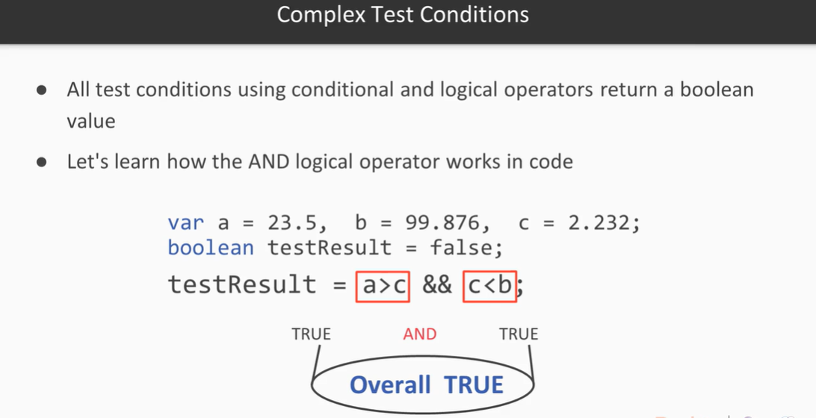

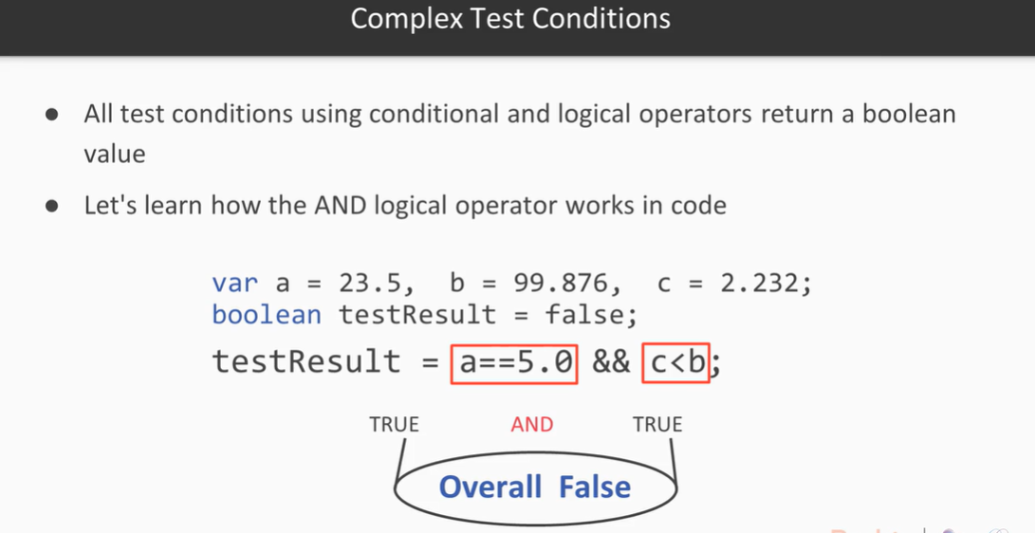

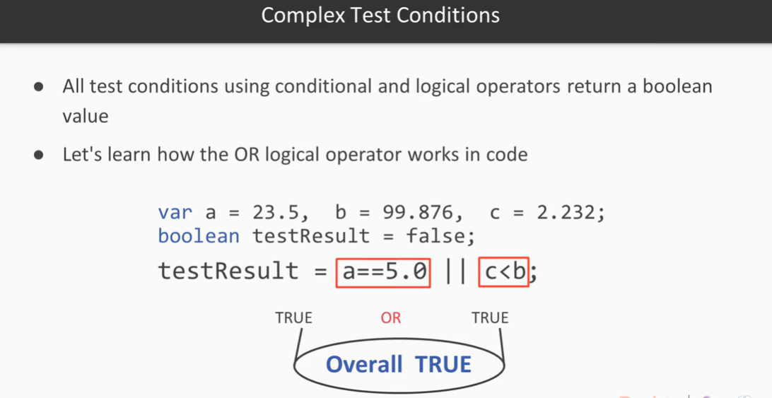

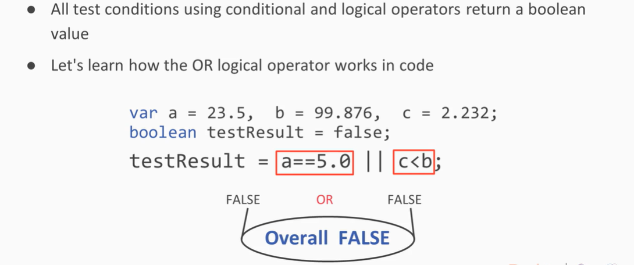

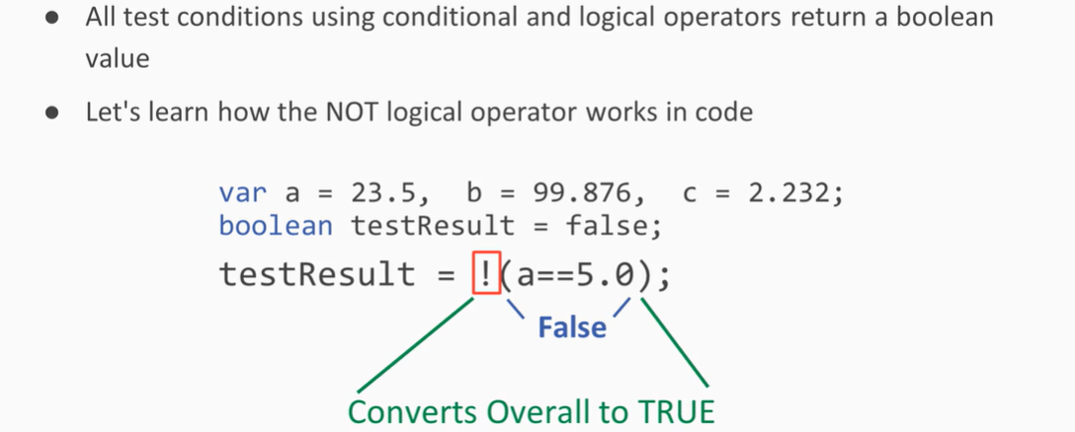

In this video you learn about the different types of loops that Java has to offer. This video will demonstrate the difference between a post test and pre-test loop and well as a sentinel pre-determined loop count loop.

* Write the demonstration code into your project
* Check if the code executes properly
* Experiment by changing the test conditions

Types of Loops:

* Pre-test – the test comes before the statements that are to be repeated (loop statements)
* Post-test – test comes after the statements that are to be repeated. This allows the loop statements to be executed at least once should the test prove false on the first go.

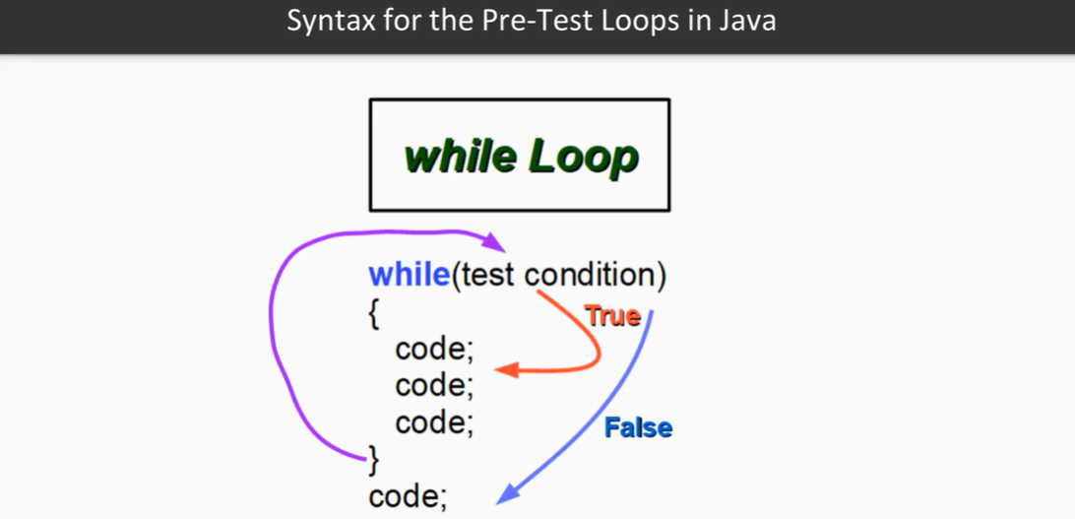

While loop example:

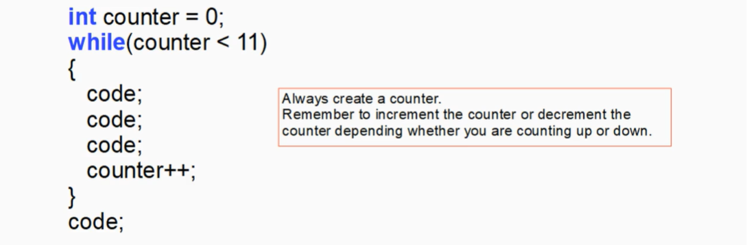

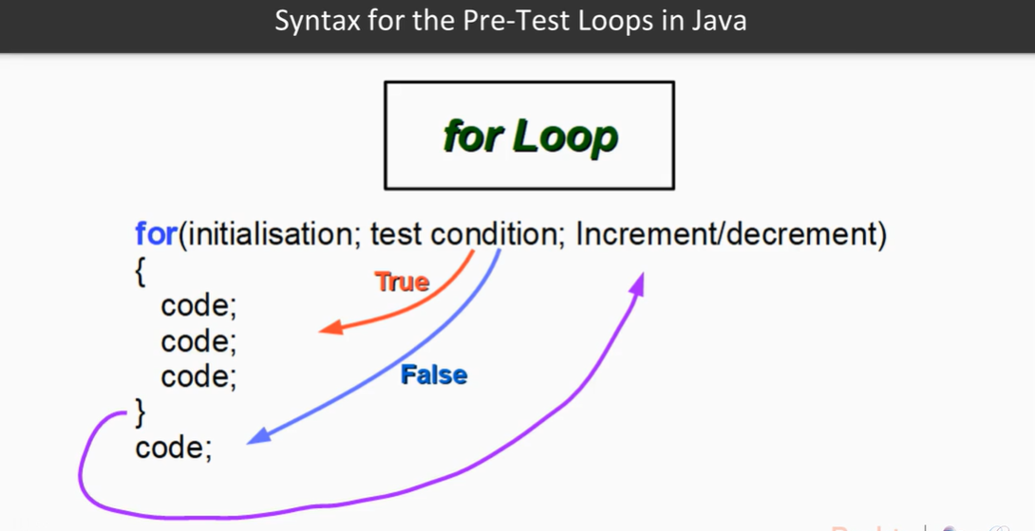

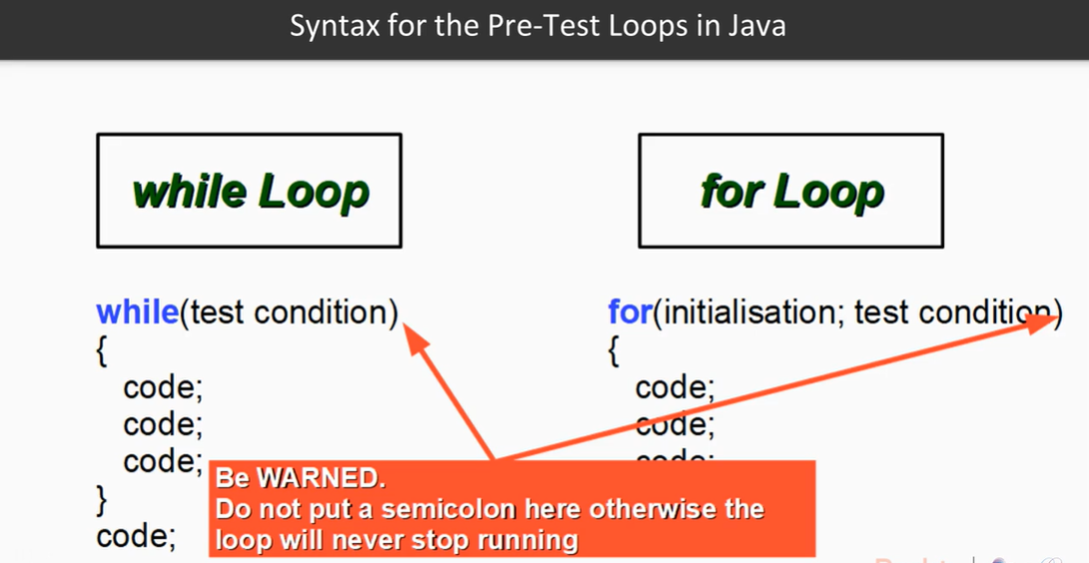

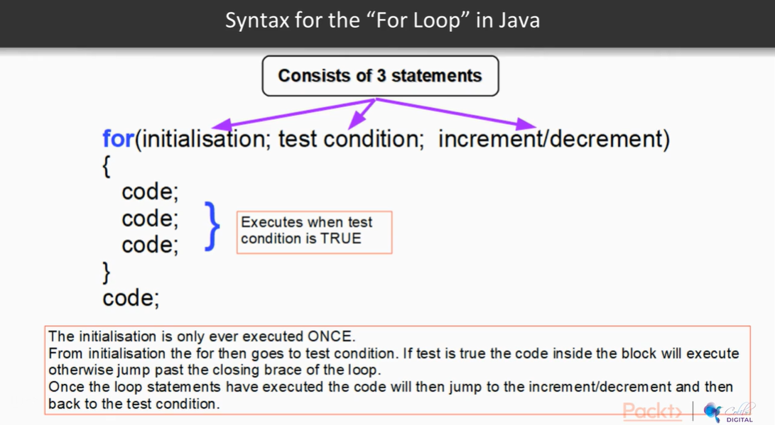

Post-Test Loop: Do-While

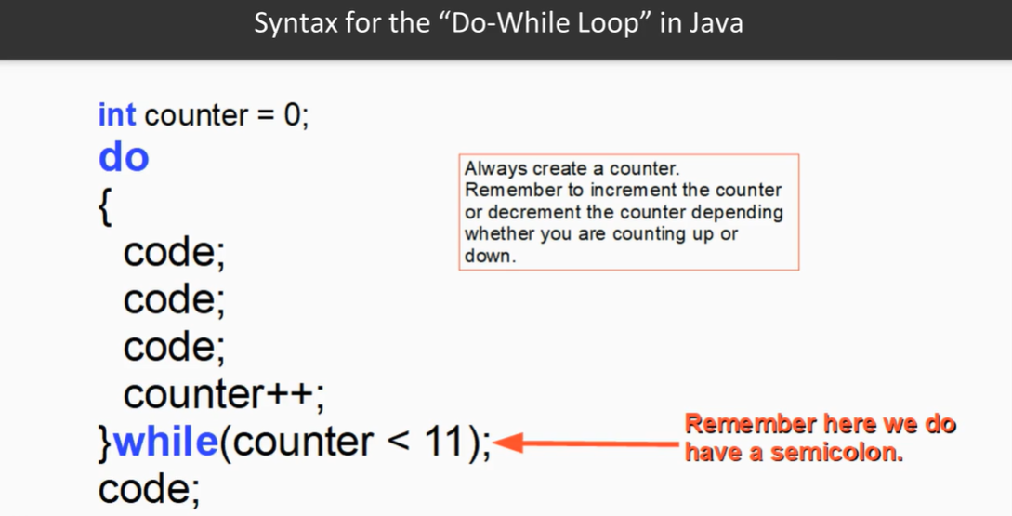

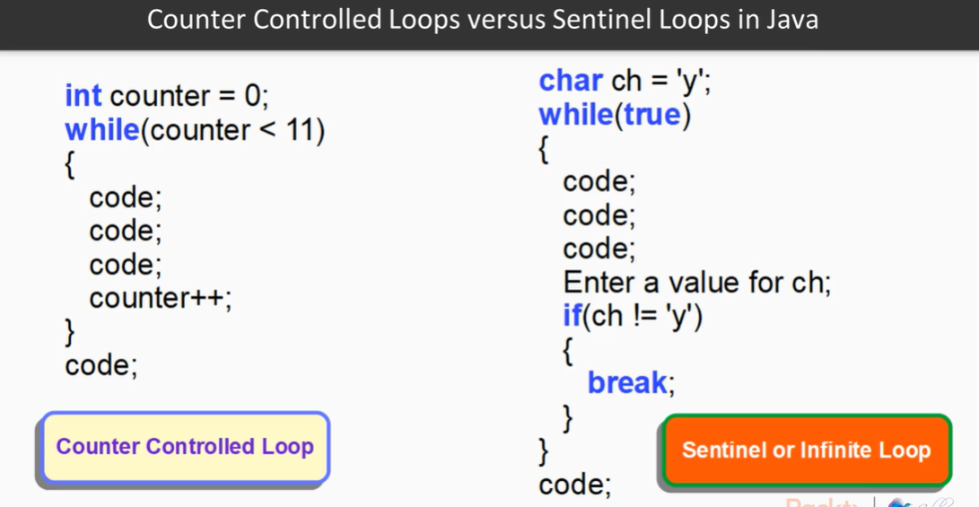

Any of the Java loops can be nested:

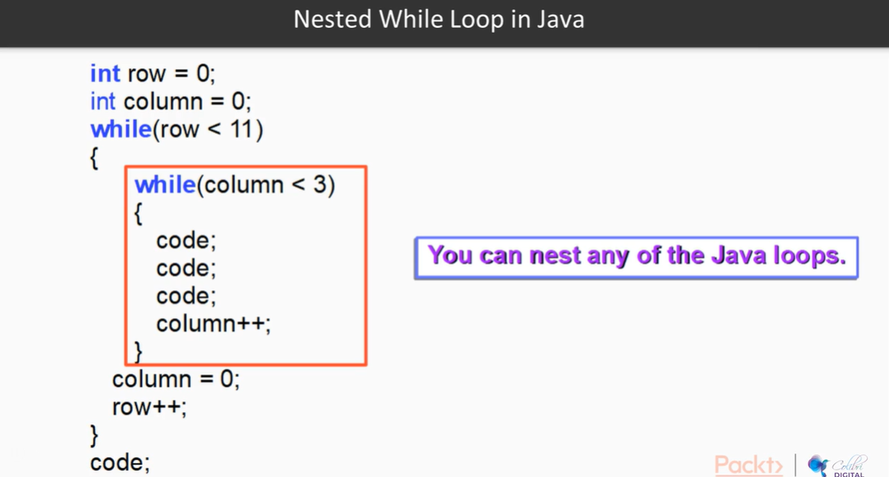

For Each loop in Java is mostly used with collections such as arrays or ArrayLists

Will cover this type of loop in a later video.

Day 2 Homework

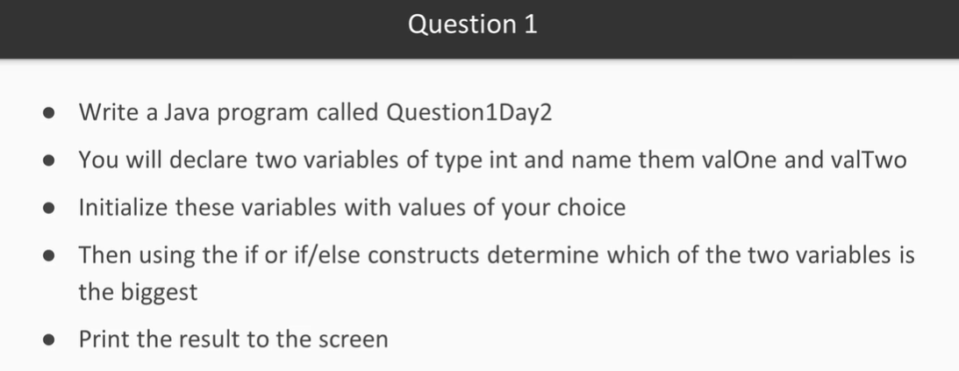

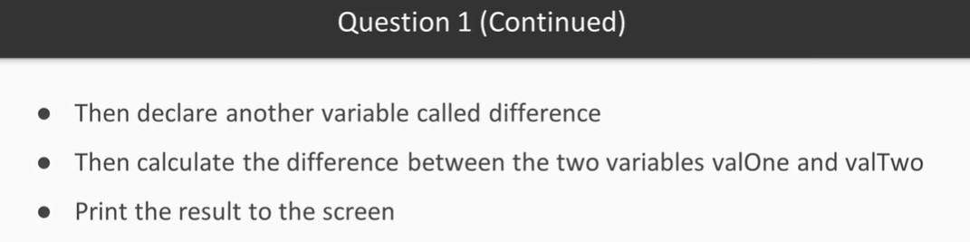

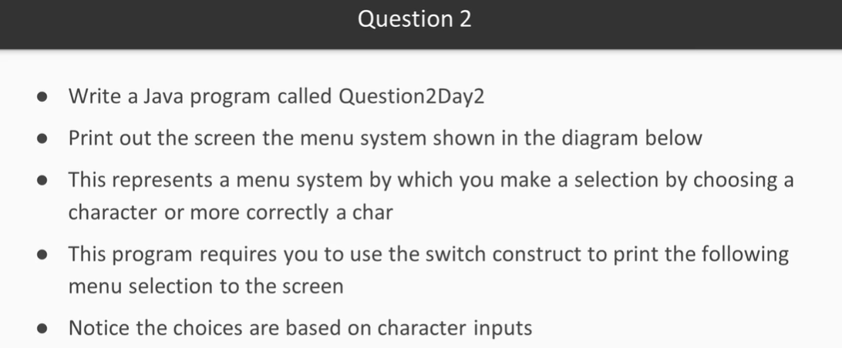

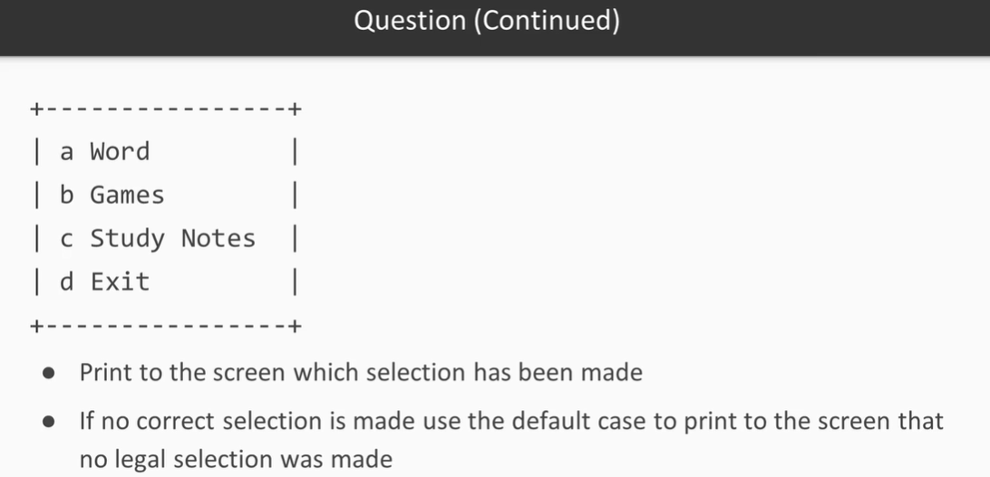

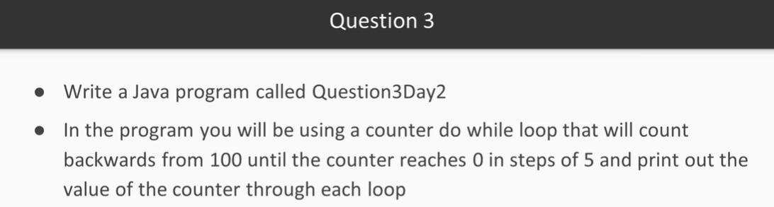

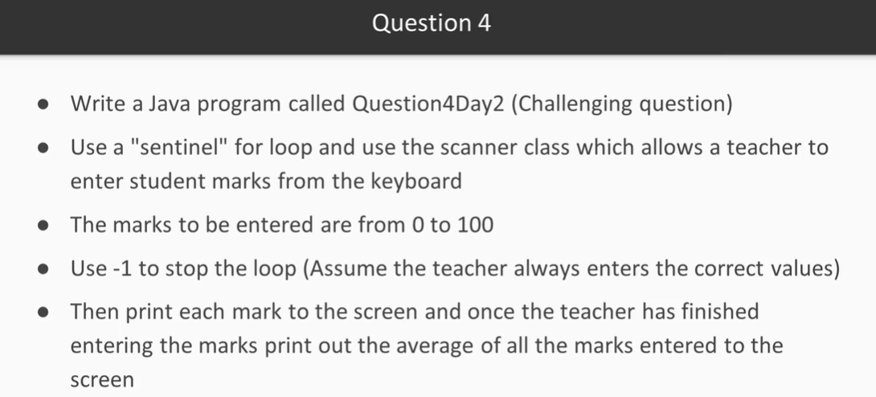

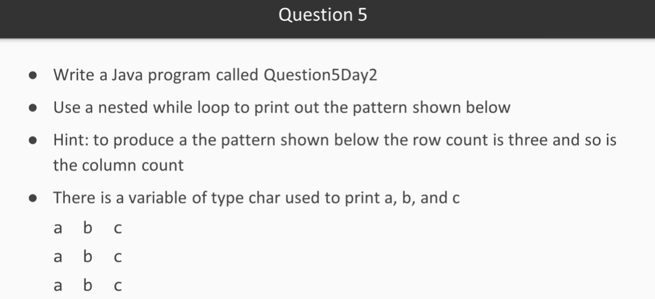

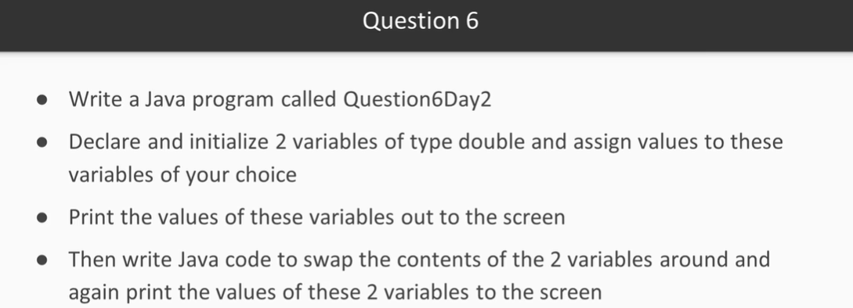

Understanding Methods – What is a Method?

* It is a block of code that has a name
* It can also take information in and return information to whoever calls it
* May be called over and over without having to always re-write the code

There are 3 Types of Methods in Java

* Constructor Method
  + User the ‘new’ keyword
* General Method (Instance Method)
  + Create an object and use the dot operator
* Static Method (Class Method)
  + Use the class name and the dot operator

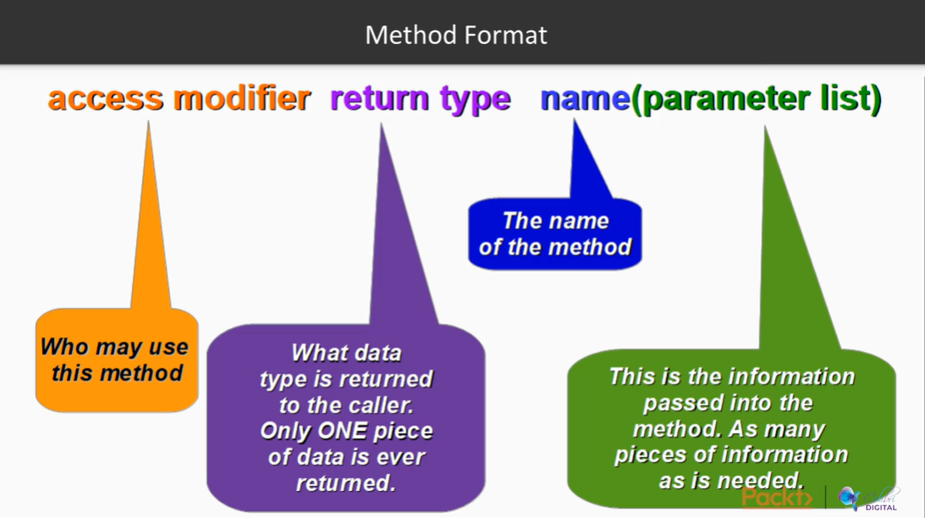

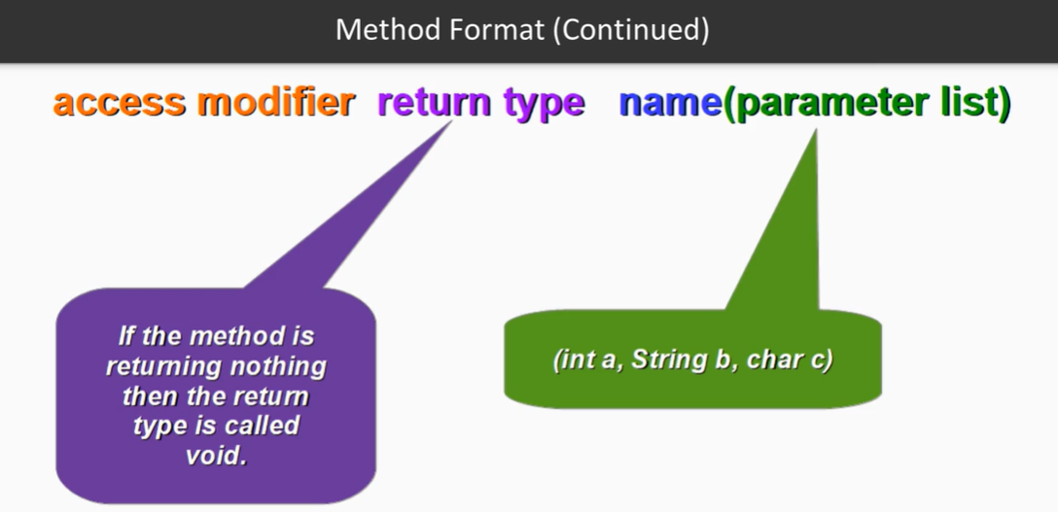

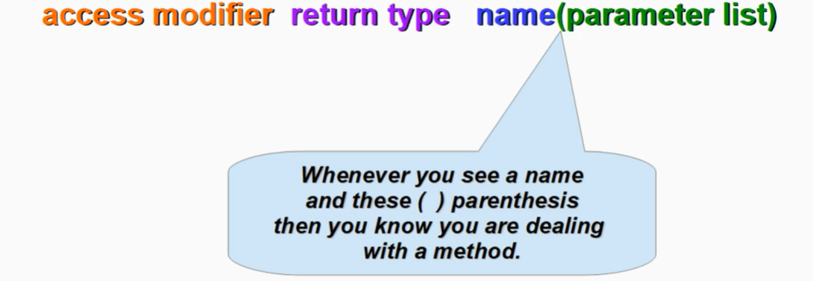

Constructor Rules:

* Constructor has the same name as the class
* It is called using the new keyword
* It has no programmer defined return type
* It is used to create an object of a complex data type
* Example using the string class, go to the documentation:

String name;

Name = new String(“Allan”);

Static (Class) Method Rules

* You do not need to create an object before you can call this type of method
* It is called using the name of the CLASS in conjunction with the dot operator
* It has only one piece of data that may be returned to the caller
* The parameter list may contain many pieces of legal data types separated by a comma

double rand; //declaration

rand = Math.random() * 100;

System.out.println(“rand = “ + rand);

What is an Object?

* An object is something that has characteristics and behavior
* Characteristics of a die (dice):
  + Cube with 6-sides
  + Each side marked with a unique integer number from 1 to 6
* Behavior of a die (dice):
  + Roll the dice and read the random face value that is facing up on the top

What is a Class?

* A class in Java programming is a code template that we can use to create objects, providing values for the characteristics and implementations of the behavior

Who Do We Protect the Data From?

* We protect the data from misuse by other Java programmers who will use the data type you have designed and may make mistakes with data or misuse data.

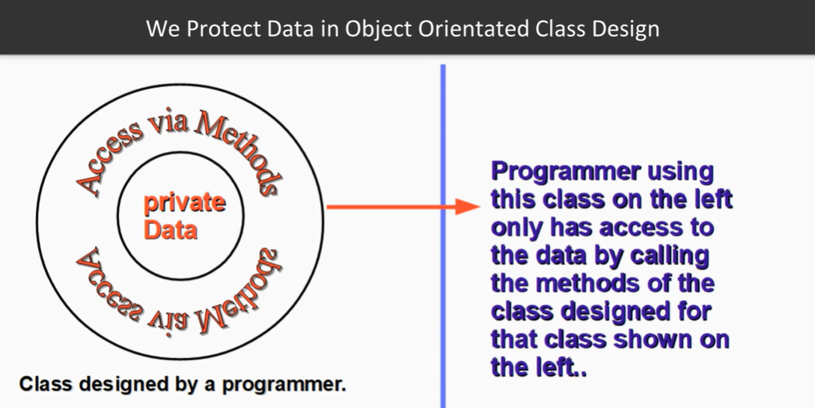

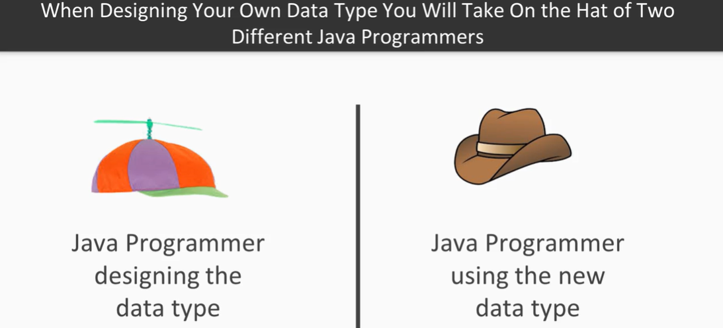

Let’s design the Dice Class. Things to Note First:

* A class consists of characteristics and methods that manipulate those characteristics
* A class consists of methods and/or constructors
* A class protects its characteristics by making them private wherever possible
* As a designer of the class you must decide what the programmer who will use your class can do with the characteristics via public methods

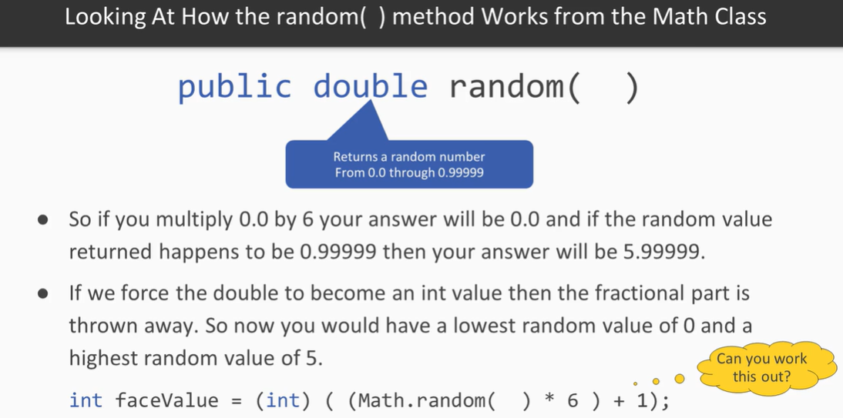

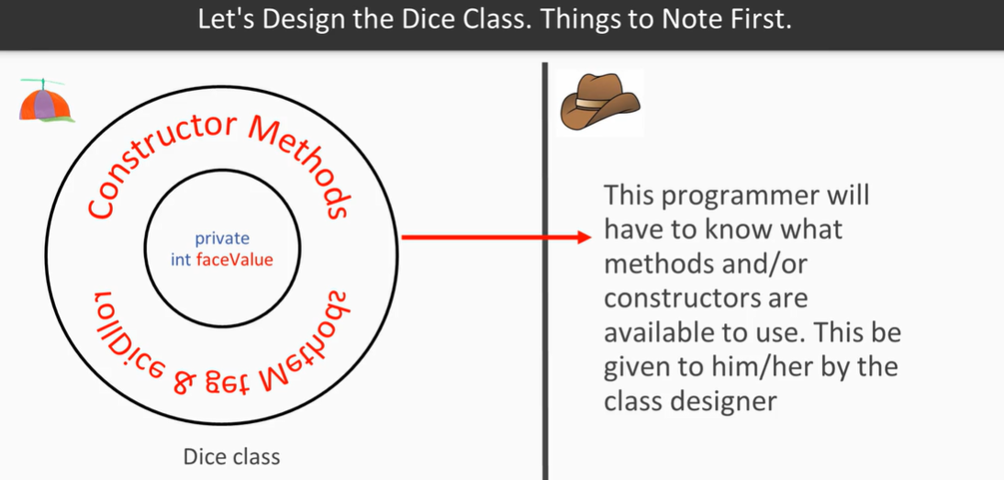

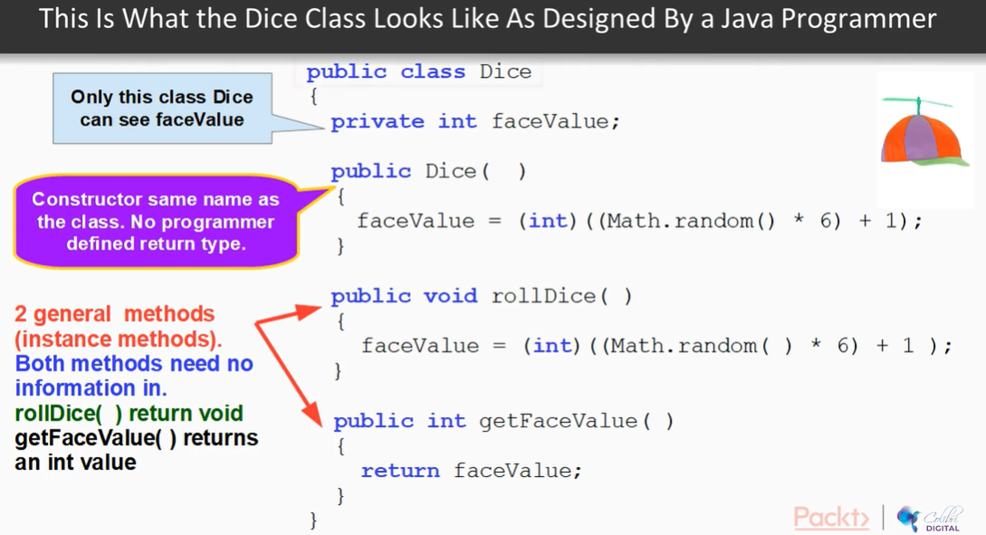

***Design a Circle Class***

Characteristics and Methods:

* Radius of type double
* Two constructors
* 1 getter and 1 setter method
* 1 method to calculate the area (area = π * radius ^ 2)
* 1 method to calculate the circumference (perimeter) (2 * π * radius)
* 1 toString() method

***What is Inheritance in an Object-Oriented Sense?***

* This is when one class inherits from another class

***Why do we practice Inheritance?***

* So as to not have to re-write code
* To practice something call Polymorphism

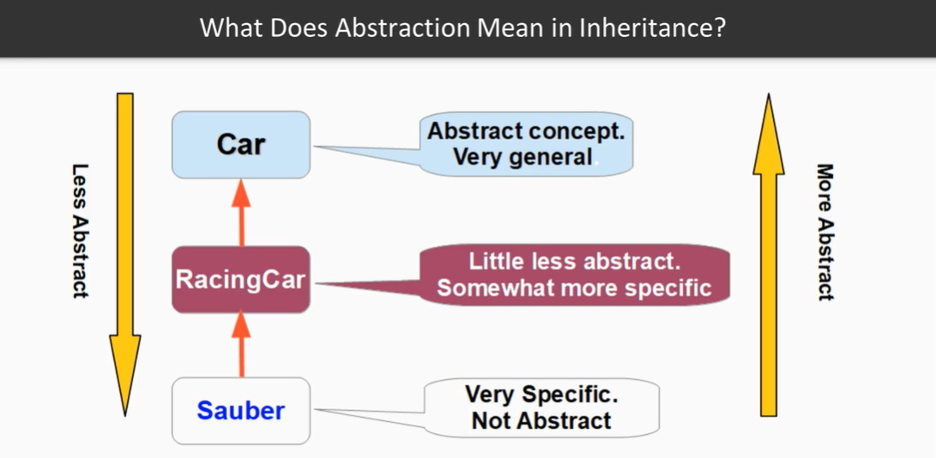

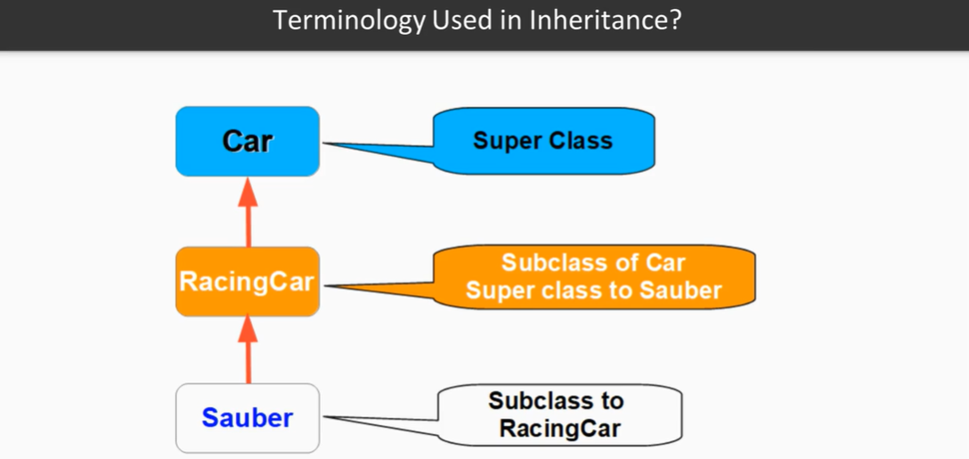

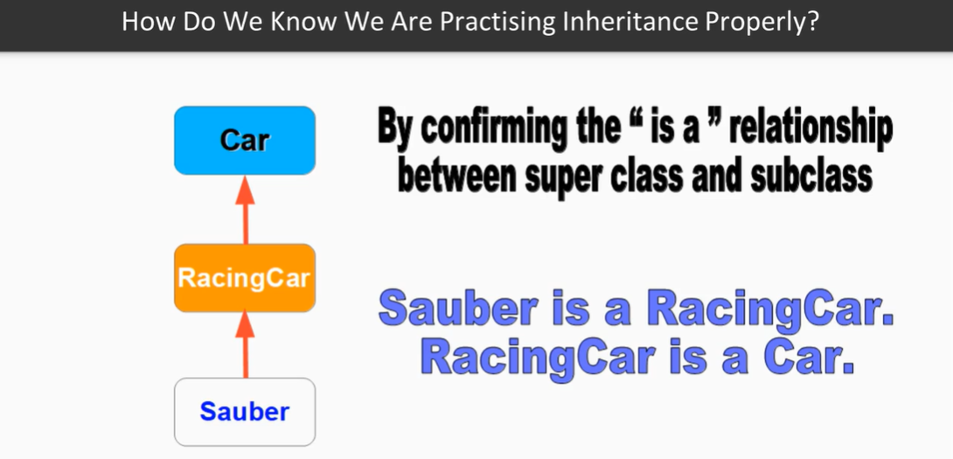

Java’s 1st Rule of Inheritance:

* A subclass may only inherit from one super class

Java’s 2nd Rule of Inheritance:

* All non-private characteristics and methods are inherited but subclasses will never inherit constructors

Java’s 3rd Rule of Inheritance:

* When constructing an object of the subclass, the superclass part must be constructed FIRST

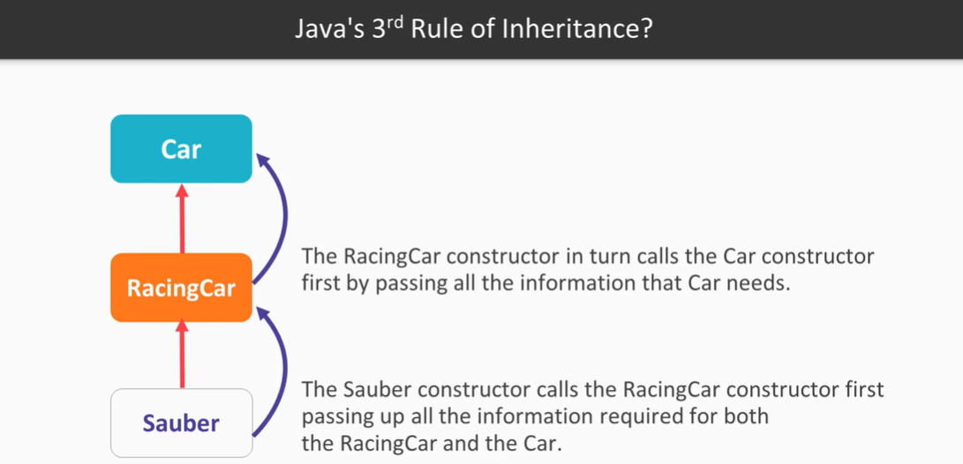

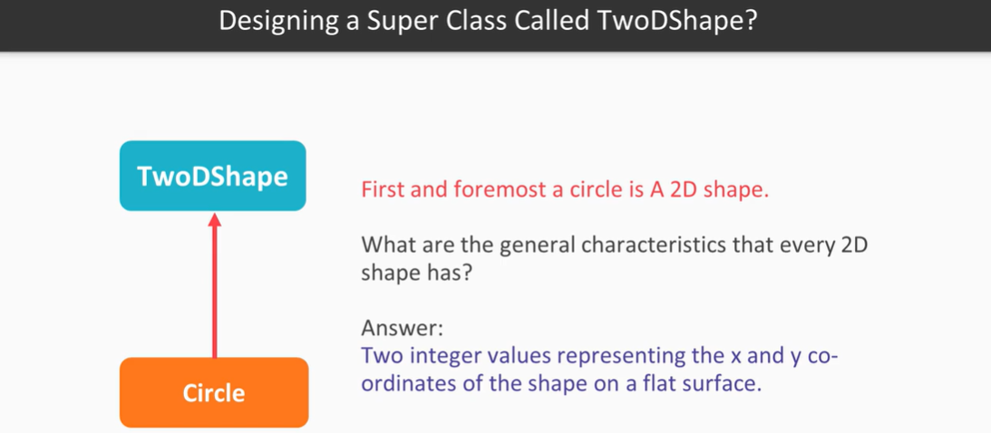

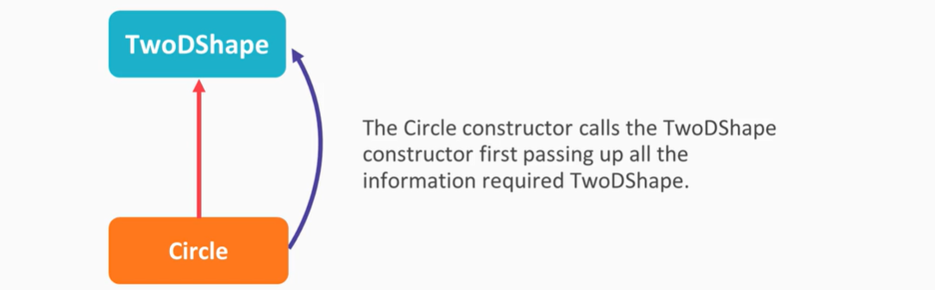

For Java 11, to use inheritance, use the Keyword “extends” -> Circle extends TwoDShape

If you cast a superclass as a subclass, that object will only understand its own methods and overridden methods. It won’t be able to call additional methods that specific to the subclass.

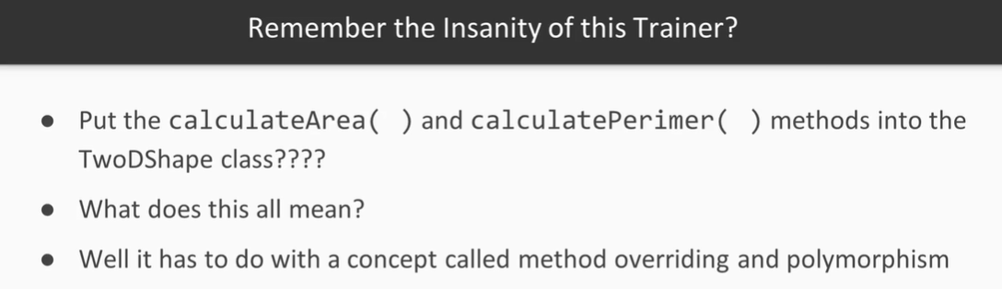

What Method Overriding is:

* That is when you have a method in a subclass that has the same signature as in the superclass
* The overridden method in the subclass has more specialized code than the corresponding method in the superclass

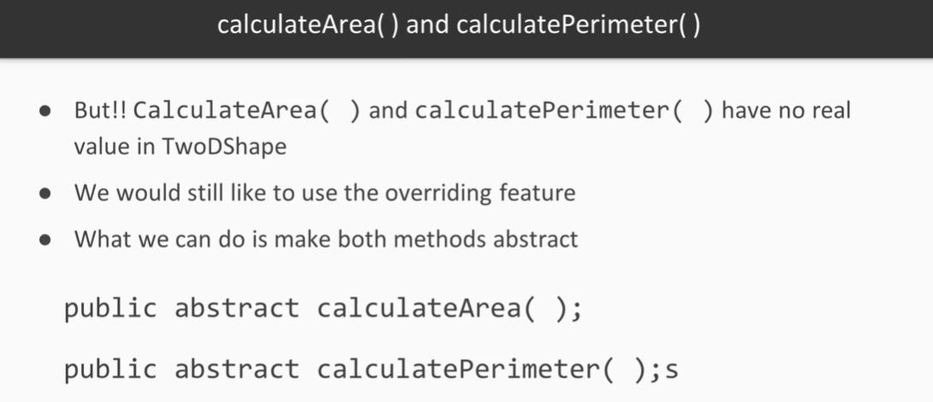

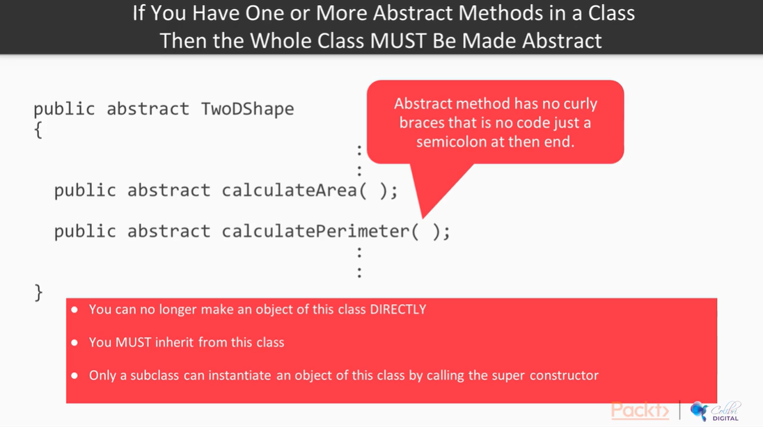

What is an Interface in Java?

* This is a special class in Java that only has public abstract methods and/or public static final variables
* Any class can implement on or more interfaces
* By implementing an interface, you are essentially injecting abstract methods or public static final variables into the class
* An interface describes behavior without specifying it

Let Us Look at Interfaces

* When implementing an interface, the programmer agrees to implement all the abstract methods or make the class he/she is working on abstract

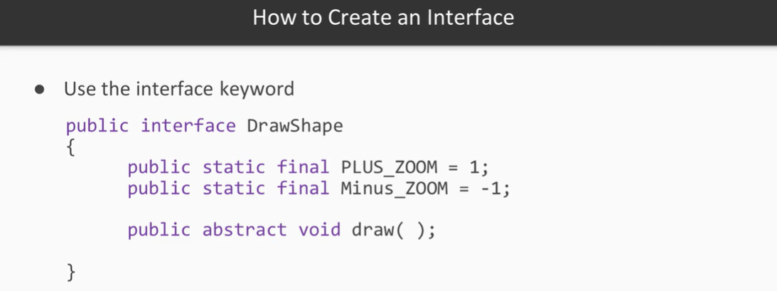

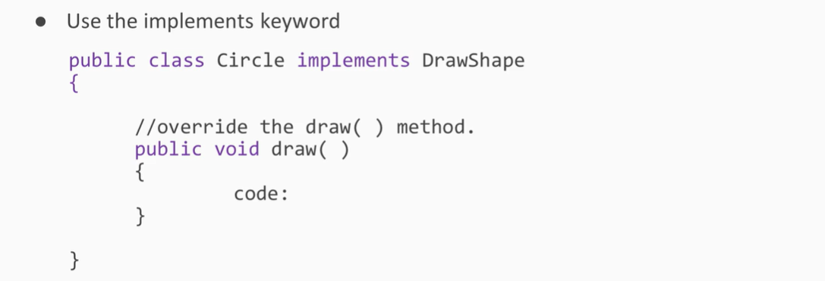

Day 3 Homework:

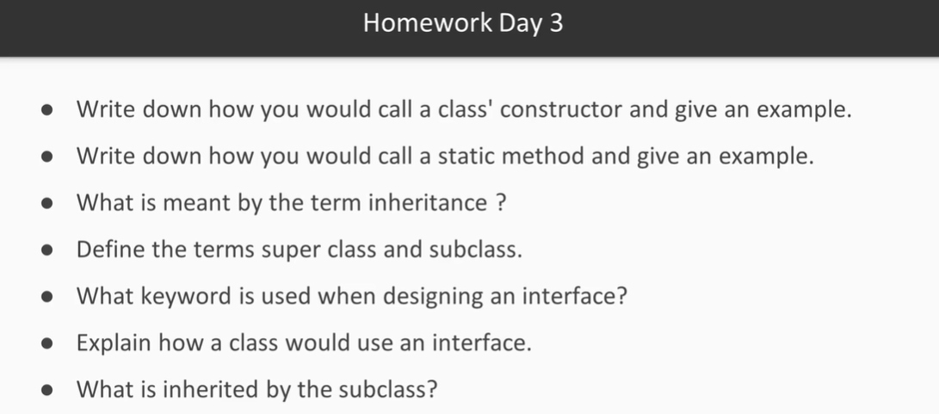

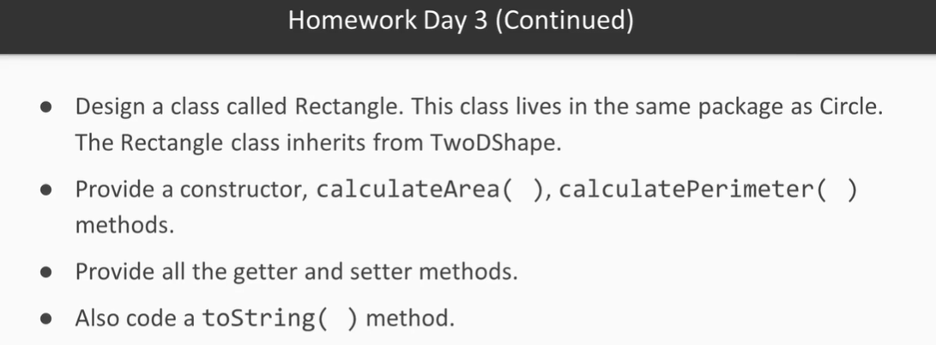

* 1. When declaring a class’ contstructor, it should simply be just public [name of class] ([parameters]), and it could be private, depending on the type of class you are writing. To call a constructor method, you just create a new instance of the class and declare it using the constructor method and passing in the parameters:

Example: public Circle(int x, int y) { super(x, y); radius = r; }

Circle c1 = new Circle(5,5,5);

* 1. To call a static method, it would simply just be [class name].[method name] and a perfect example would be Math.random()
  2. A subclass that inherits or receives the characteristics and methods/behaviors of a parent/superclass, but NOT the constructor
  3. A superclass is a parent class and is inherited from and the subclass is the child class that inherits from the parent. It is generally assumed that anywhere a parent class is used in the code, it can be substituted out with a child class.
  4. extends
  5. To use an interface, a class would use the keyword Implements at the top, and then would have to implement each of the defined methods from the interface. It doesn’t have to use them, but they must be implemented.
  6. The characteristics and methods/behaviors of a parent/superclass, but NOT the constructor

Day 4 – Learning Primitive Arrays

In this video you will understand the rules regarding the workings of primitive arrays.

You will also understand that arrays are objects and be able to create arrays of various data types. You will also learn how to manipulate individual elements within an array.

* Write the demonstration code into your project
* Run the demonstration code and make sure it runs as expected
* Experiment by manipulating elements within the array and printing the new results to the screen

Think about this:

* You have to process within a Java application 200 temperatures gathered from weather stations in your area.

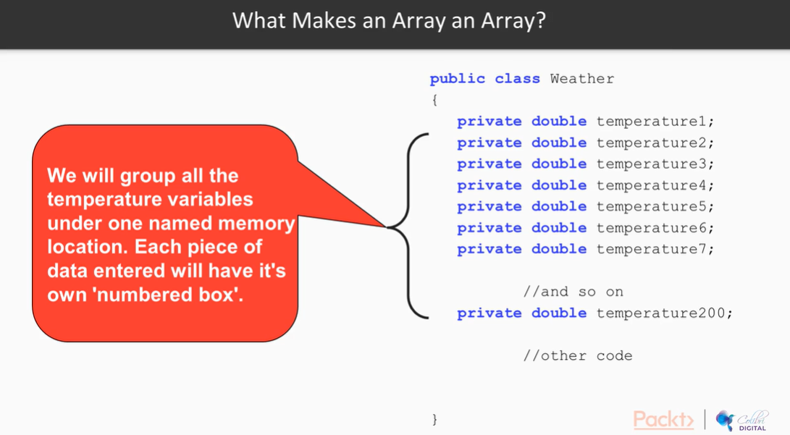

Square braces [] are used to denote an array. In arrays the square braces are used in three different circumstances/context:

1. Declaration
2. Initialization
3. Position

Facts about Arrays:

* Arrays are a named collection of variables of a certain data type
* In an array the lowest address in memory is associated with the first element
* In Java arrays are objects
* This implies that operations common to all objects may be performed on arrays
* Once the array has been created and initialized, on can access and manipulate the individual array elements
* You cannot change the size of the array once it has been created
* There are three circumstances when the square braces are used when working with arrays:

double [] temperatures;

temperatures = new double[200];

temperatures[21] = 31.6

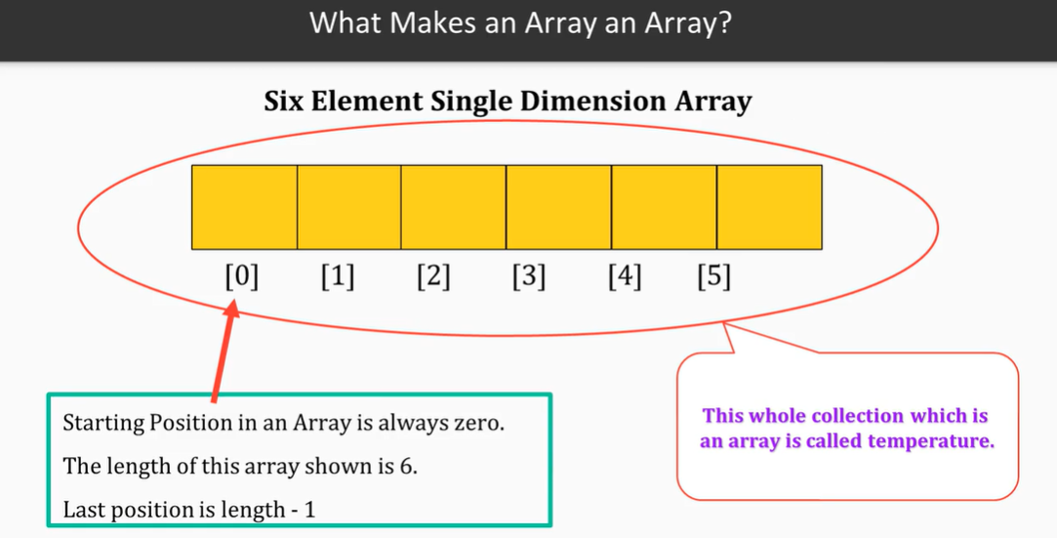

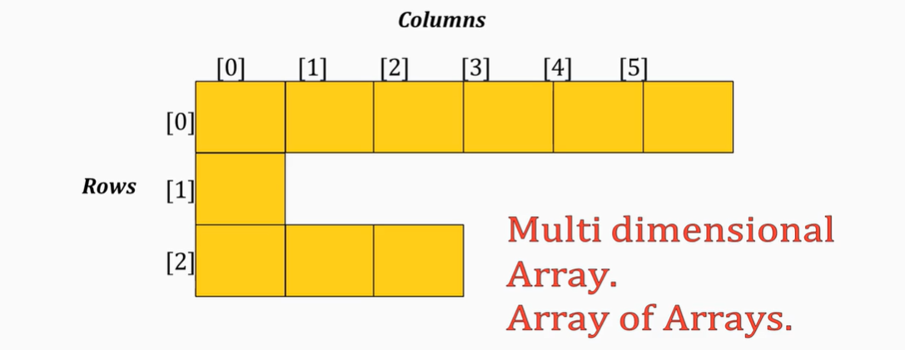

Multi-dimensional arrays – each row does not have to have the same number of elements. These are often referred to as an array of arrays.

All inheritance hierarchies eventually inherit from Object

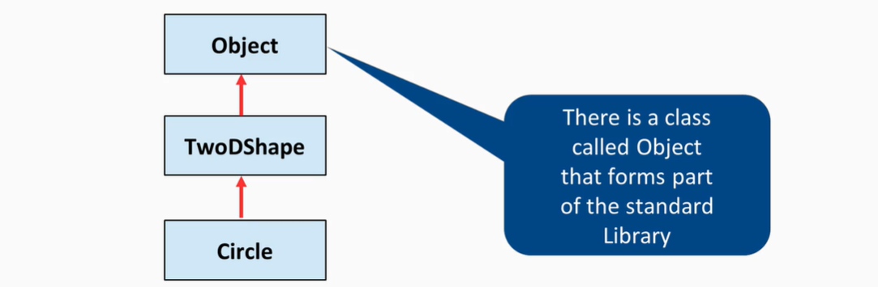

What is an ArrayList?

* A fancy array type object which can grow as you add elements and shrink as you delete elements
* There is more functionality associated with ArrayList in that you can find(), insert(), and so on

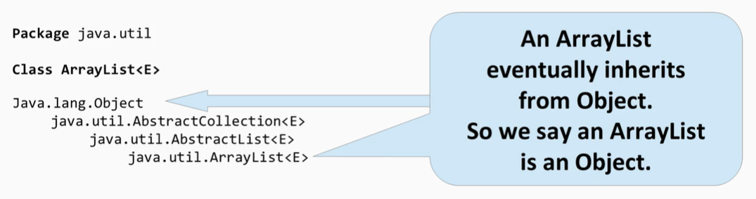

Facts about ArrayList

* Can *only* take in object types
* Because every class eventually inherits from the object class you can insert ANY kind of object into the ArrayList
* This is not always a good idea

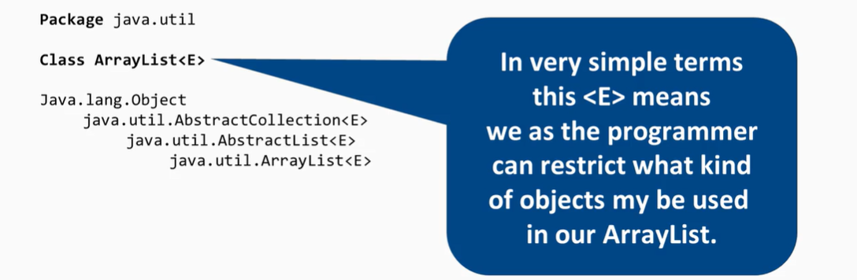

* An ArrayList *cannot* take in primitive data types such as int, double, Boolean, char, and so on

In order to insert a primitive data type, you have to be able to convert it to an object

Wrapper Classes

* In order to insert a primitive type into an ArrayList, we need to make an object out of them
* The designers of Java gave us a set of classes called Wrapper classes that allow us to do this:

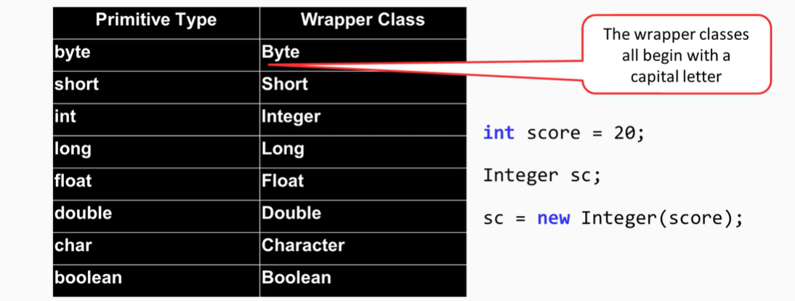

Methods we can use in ArrayList are available within the documentation

This video will give you a good understanding of how sort an ArrayList. First you will need insight into the Comparable interface and this video demonstrates that using the Circle class.

This video then shows you how to use the Collections.sort( ) method.

* Write the demonstration code into your project.Read the official documentation on the comparable interface. Check that you understand the code in the Circle class
* Check to see if the test code executes properly
* Experiment by creating a new ArrayList say of type String or Date

Sorting an ArrayList

* In order to sort an ArrayList, it must contain only one type of object
* The objects that are stored in the ArrayList must all have implemented a comparable interface

Java has a feature called autoboxing where a primitive data type will automatically be wrapped in the appropriate wrapper object.

In the video you learn about the basic features of the HashMap and how to manipulate very basically.

* Write the demonstration code into your project. Read the official documentation on the HashMap
* Check to see if the code executes properly
* Experiment by creating your own HashMap and using the other methods to manipulate it

What is a HashMap in Java?

* A Map based on collection class that is used for storing key-value pairs
* Denoted as HashMap<Key, Value> or HashMap<K, V>
* Part of Java’s collection framework of classes
* It stores the data in (Key, Value) pairs
* To access a value, one must know its key
* Doesn’t allow duplicate keys, but allows duplicate values
* This class makes no guarantess as to the order of the map
* In particular, it does not guarantee that the order will remain constant over time
* Hashing is a technique of converting a large String to small String that represents the original String

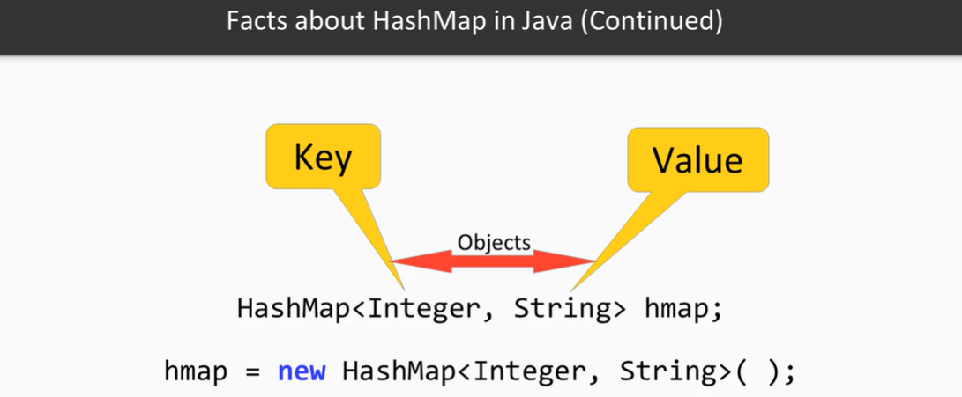

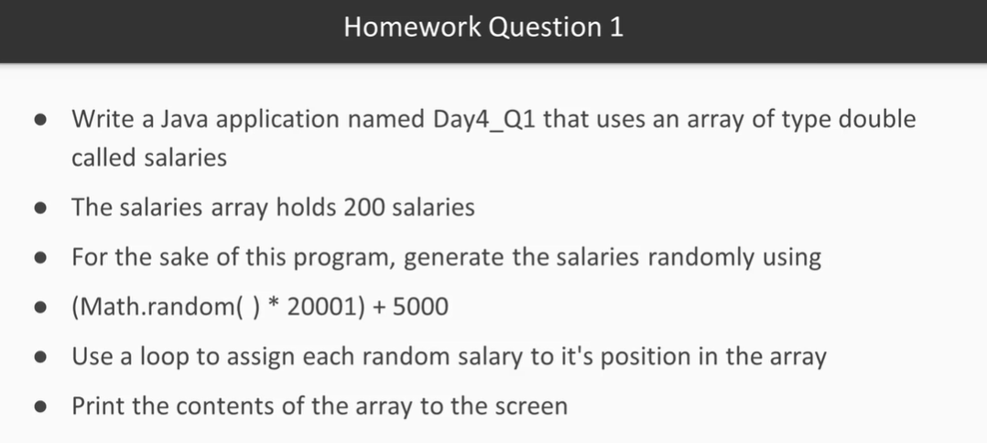

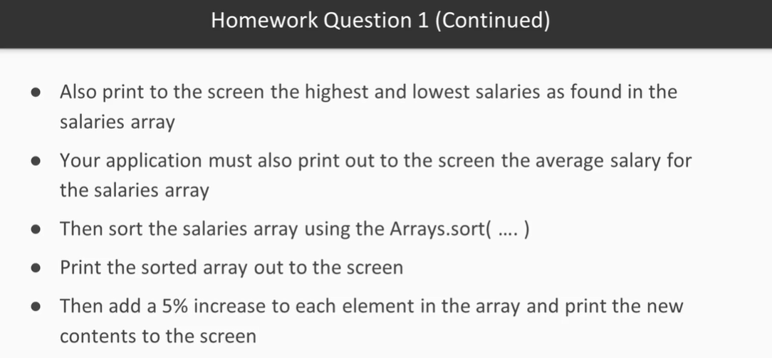

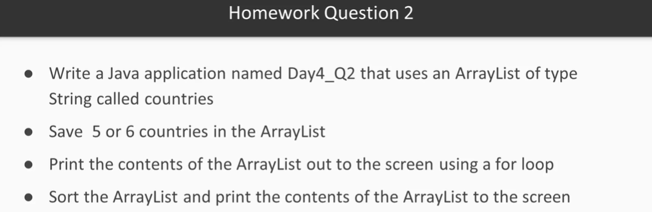

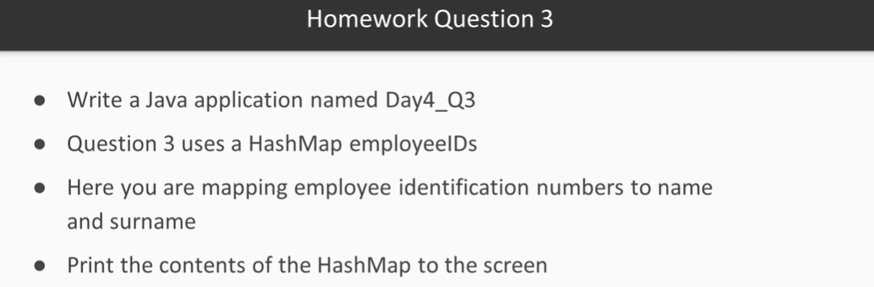

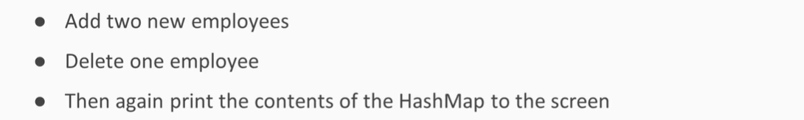

Day 4 – What is I/O in Java?

* I/O in Java is the data input to your Java application and the data sent out from your Java application
* In this case, we are outputting data from the application to a file. First, the application needs to connect to the file. We look at I/O as streams, so we would “stream” the data from the application to the file.

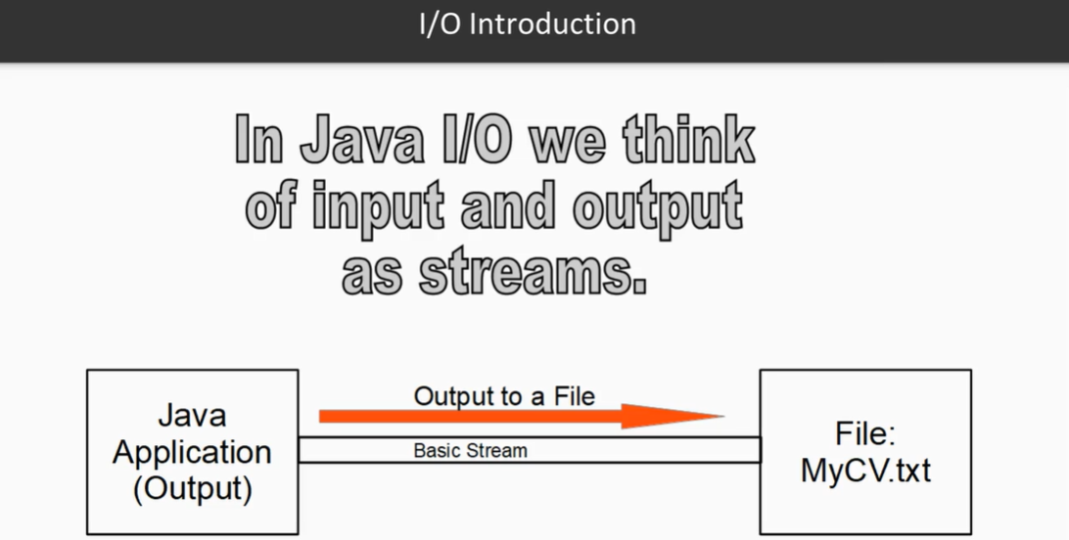

* In the following example, we are inputting data from the source file into an application. Again, there first needs to be a connection between the file and the application for the stream.

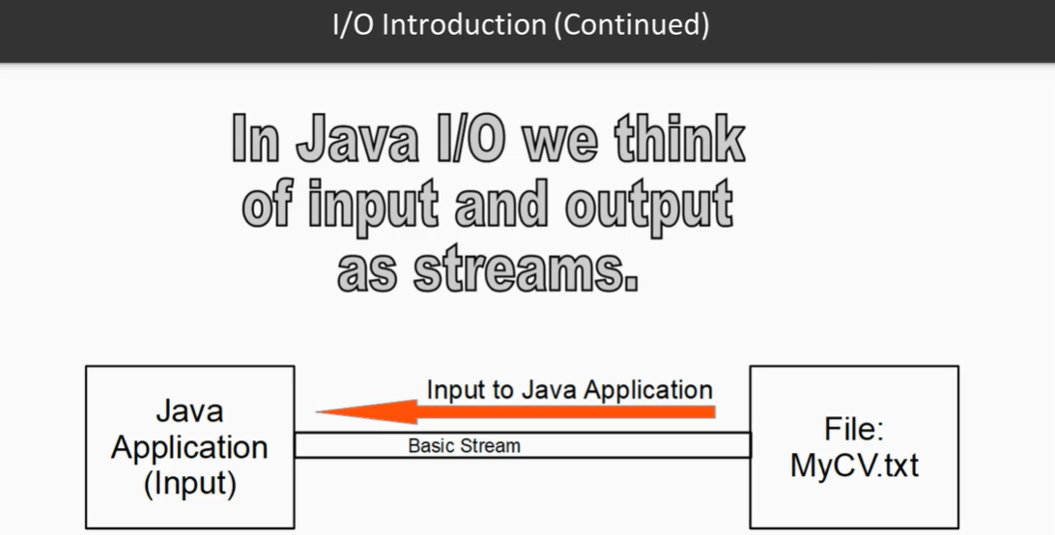

Consider the following:

What is the difference between the number 35 (plain numeric) and the String “35” (plain text)?

* They are represented completely differently within the computer when converted to ASCII code. The number 35 would just be represented as 35, but the String would be completely different.

The File class represents the operating system’s file structure.

* In Windows, it would look like this – C:\temp\budget.txt
* In Linux, it would look like this - /temp/budget.txt
* An object of this class can tell you a lot about the directory you are working in and give you information about a file should you be working with that file

Java has 2 sets of I/O classes:

* One for numeric type of data such as 35, mp3, mp4, and so on
* Another set for text type data such as “35”

Two hierarchies are classified as Character Streams and Byte Streams. Character Streams are for Strings and Byte Streams are for numeric:

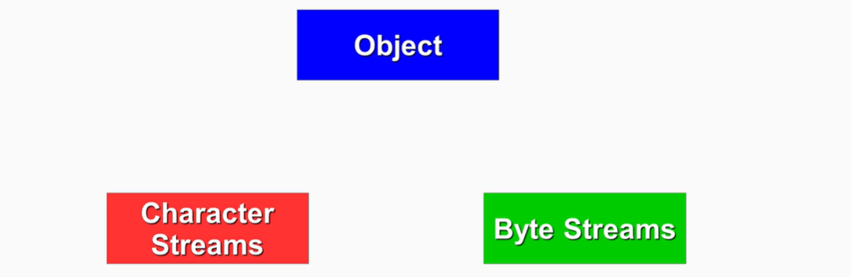

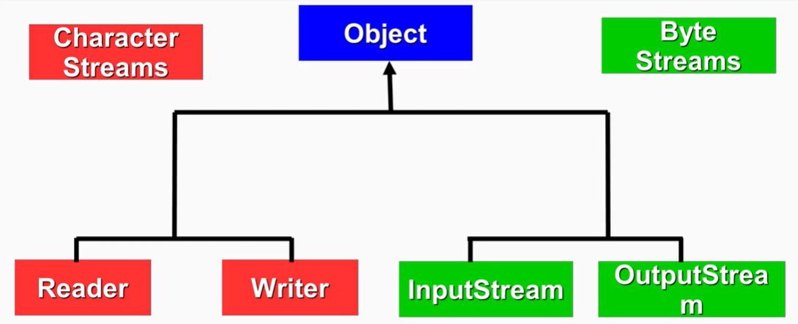

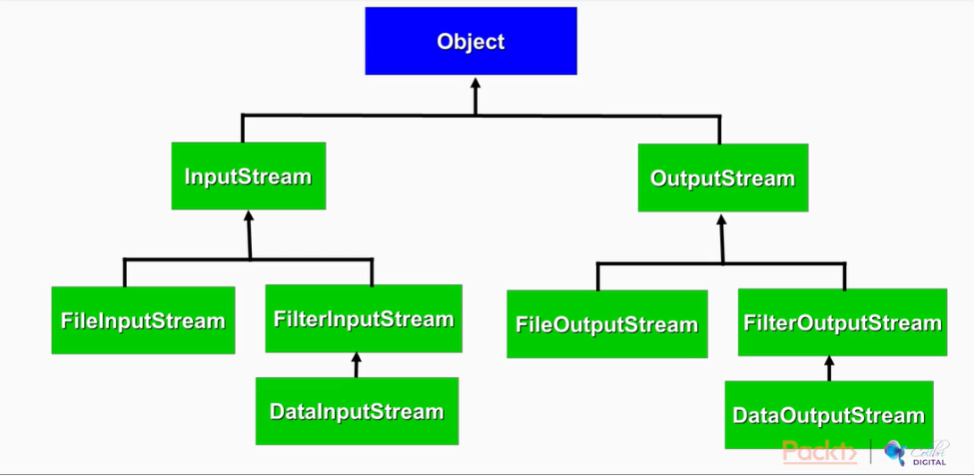

FileWriter is a very basic class that only makes a connection for you, but its functionality is very limited. To enhance the functionality, we will want to wrap another connection type class around it to give us additional functionality.

When we are taking text type data into the application, we will want to be using Readers. In the case of reading from a file, you would want to use a FileReader.

One of the helper classes is a BufferedReader – this is important because if we had to go to a file every single time we had to read from it, that would be very slow.

The slowest part of a program is reading from the file systems, so what we want to be able to do is read chunks at a time, put them into memory, and then read them from memory. That is a lot quicker and a lot more efficient.

So, whenever you a reading into a Java application try and buffer the input.

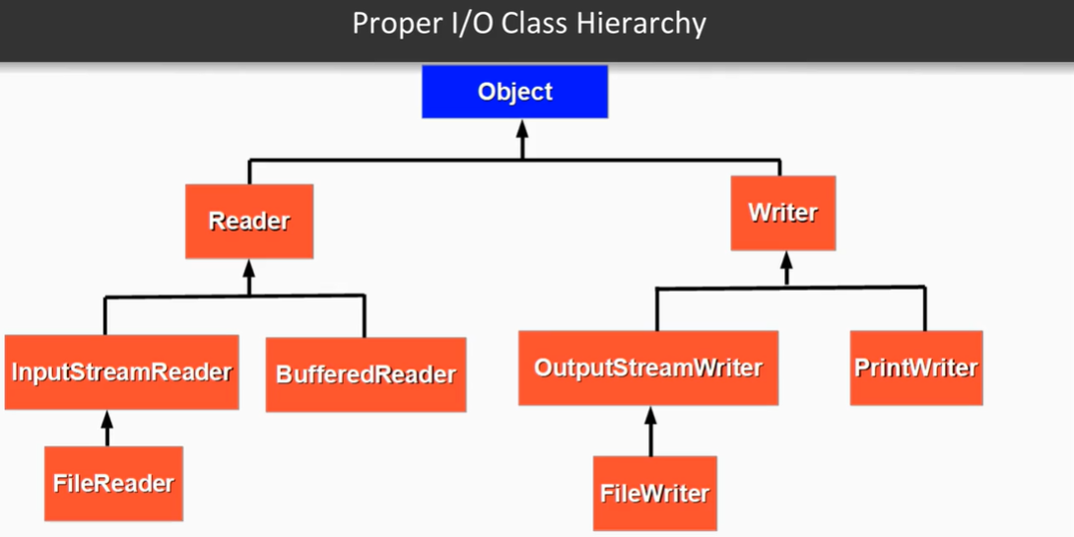

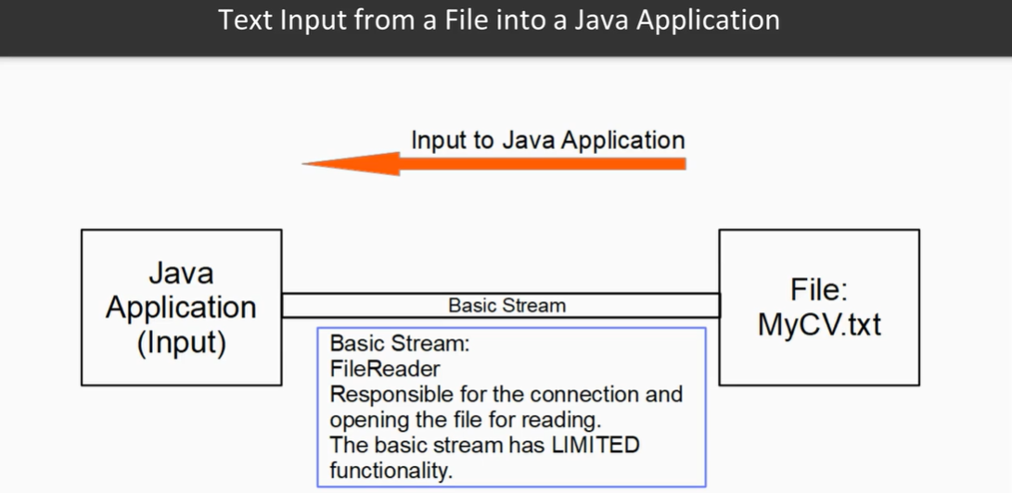

***IMPORTANT*** - NEVER FORGET TO CLOSE STREAMS – If you don’t close streams, there is a possibility that a file can become corrupted. In addition, the memory that is being used to make the connection will continue being used/occupied until your computer is shut off.

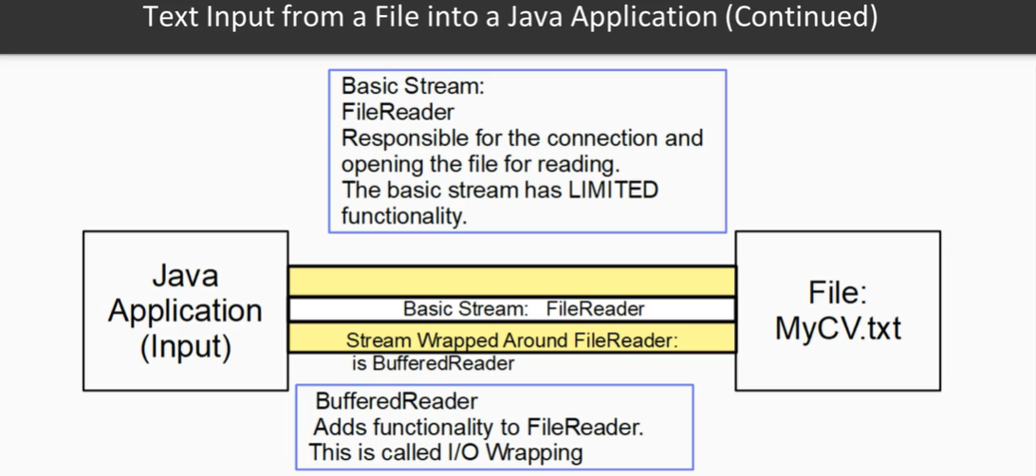

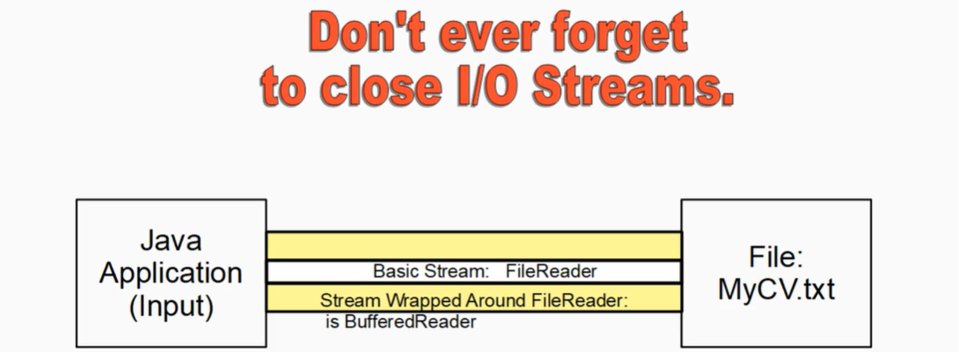

This video will teach you how to read text from a text file using the File class as well as the FileReader and BufferedReader classes.

* Write the demonstration code into your project. Read the official Java documentation on the classes used in the demonstration software
* Check to see if the demonstration code executes properly.
* Write your own program to read a simple text file using an absolute path

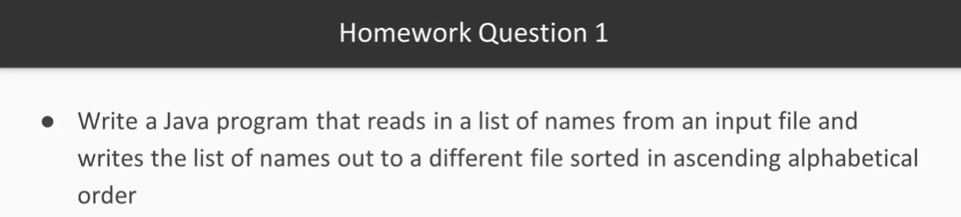

Day 6 – Lambda Expressions

In this video you will get to learn what a lamba expression is and also the need for functional type programming.

* Write the demonstration code into your project
* Check to see if the demonstration code executes properly

What are Java Lambdas?

* They are expressions and are Java’s first step into functional programming
* A function which can be created without belonging to any class
* A lambda can be passed around as if it was an object and executed on demand

Why do we use Lambda Expressions?

* It enables functional programming
* It produces concise code
* It supports parallel programming

Lambda Basics

* Up to now a method has always had to be defined within a class
* Looking at the old way of injecting code into a method

How to develop a Lambda Expression?

* Use printMessage from our example, but before we go forward, ask yourself this:
  + This is valid, right?

int score = 31; //of course it is

double vat = 0.15; //inline values

But – can you assign a block of code to a variable? Can you assign a function or a method to a variable?

fVariable = public void printMessage() {

System.out.println(“This is Java”);

}

If you’re going to assign a function to a variable, you do NOT need public void or the function name:

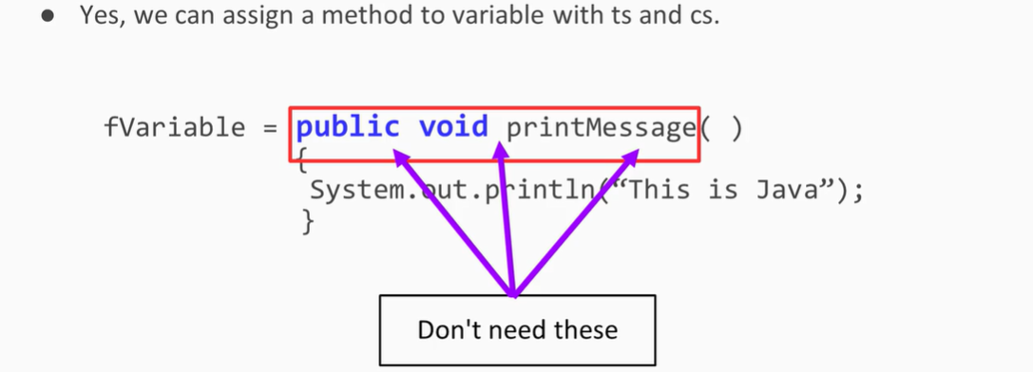

All you need to have are the open and close parentheses along with the hyphen and the greater than symbol:

fVariable = () -> { System.out.println(“This is Java”); }

Understanding Streams

Looking at Lambda Expressions with a Collection

*Take a look at how it is possible to iterate over a collection using the new forEach(action) method*

What is a Stream?

* The java.util.Stream package consists of classes and interfaces that allow for functional-style operations over elements within a collection
* A Stream allows the programmer to process data using plain English-type language

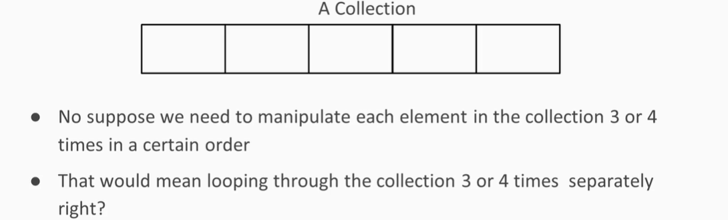

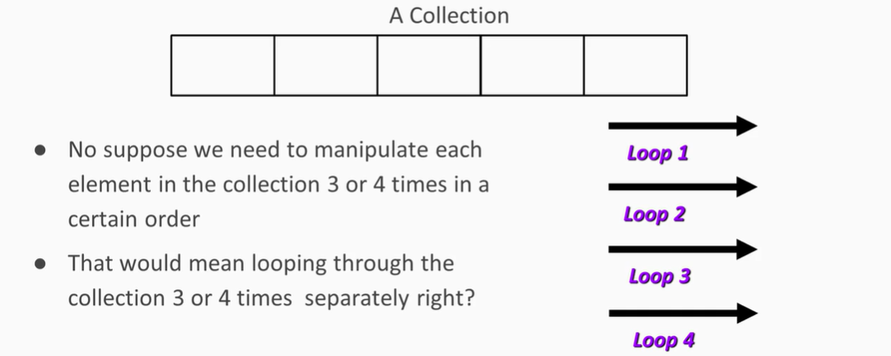

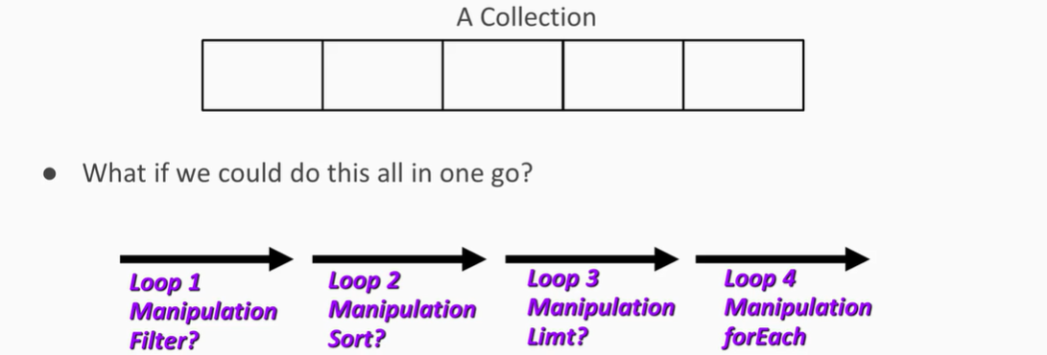

What is Functional Programming?

* A paradigm shift in thinking
* Considers mapping input to output without side effects
* Treats computations as the evaluation of mathematical functions

Why use Functional Programming?

* Functions are easy to test
* Debugging is made easier
* Parallel Programming is made possible

Differences between Object-Oriented and Functional Programming

* Functional Programming focuses on evaluation of functions while OOP is based on objects and methods
* In OOP you store data in objects and have methods that operate in that data while in functional programming we focus on transforming data by creating new versions of that data and manipulating it

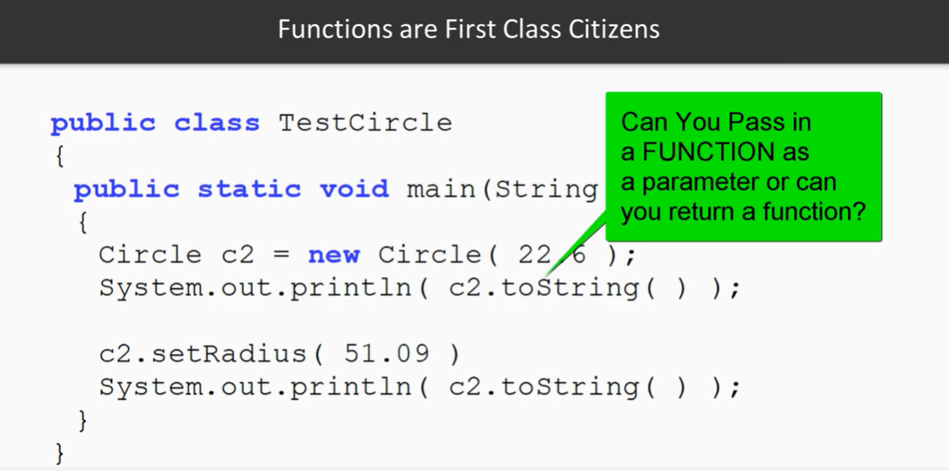

Right now, the answer is NO, but with functional programming, you *CAN.*

Homework Day 6

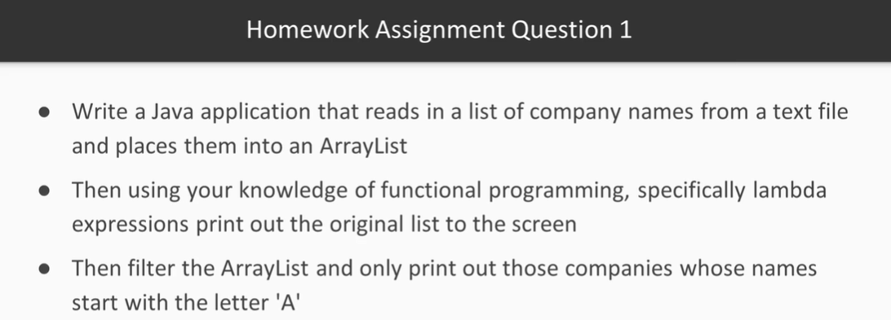

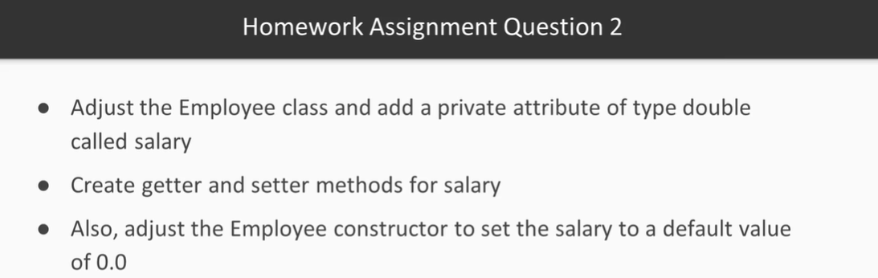

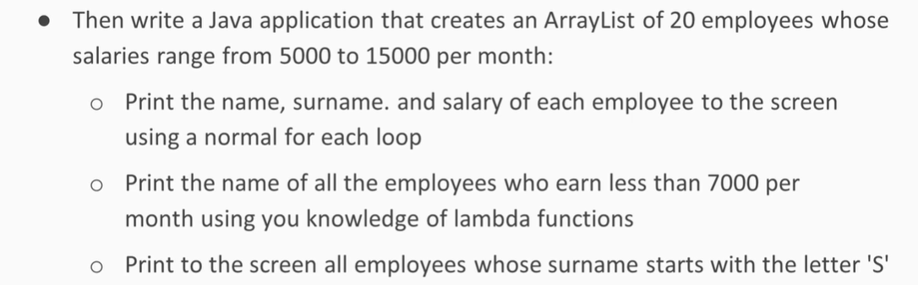

Lambda expressions are the method without name i.e. Anonymous method. In other words, Lambda expression is a function that can be passed around and referenced as an object.

***Day 7 – Exception Handling***

In this video you will get to learn about the exception handling mechanism in Java. You will get to know what automatic exceptions are versus checked exceptions. You will also learn how to trap exceptions.

You will get to understand that exception handling is essentially a messaging system.

* Go through the video carefully and make sure you understand the concepts
* Make sure the demonstration code executes properly
* Experiment with the code and see where the code jumps to under certain circumstances

Exceptions in Java

* An exception in Java is an abnormal condition that arises in a code sequence at RUN TIME
* Example: a RUN TIME error

Two types of errors in Java: Compile-time Error and Run-time Error

Two basic approaches to handling errors in Java

* Resumption
  + Here, we look at the error and we find out if we can actually fix the error and carry on with the program. We expect the error to be handled in such a way that the situation that caused the error may be corrected and then the code that was faulty can be re-executed.
* Termination
  + This is when you get an error and unfortunately, the error is of such nature that you have to then terminate the program. These types of errors are serious to where it would be impossible for the program to continue successfully.

Exception Handling Fundamentals in Java

* A Java exception is an object that is thrown when an error occurs
* The error object can only be detected during runtime inside methods, and it can be in any type of method – it can be in a constructor method or a general method, or it can be in a static method

In order to be involved with Exception handling, you have to extend from the Exception super class:

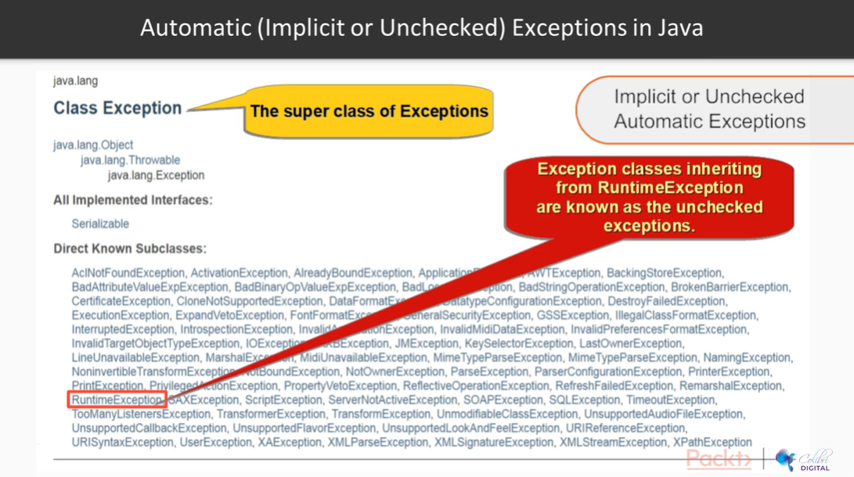

There is a special class of exceptions called the implicit or automatic exceptions, and these are exceptions that we as programmers do not have to check for. The run-time will check automatically and produce messages showing the errors without us having to actually check for them.

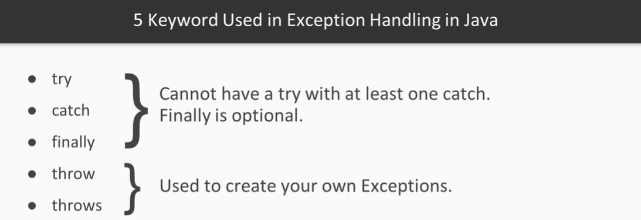

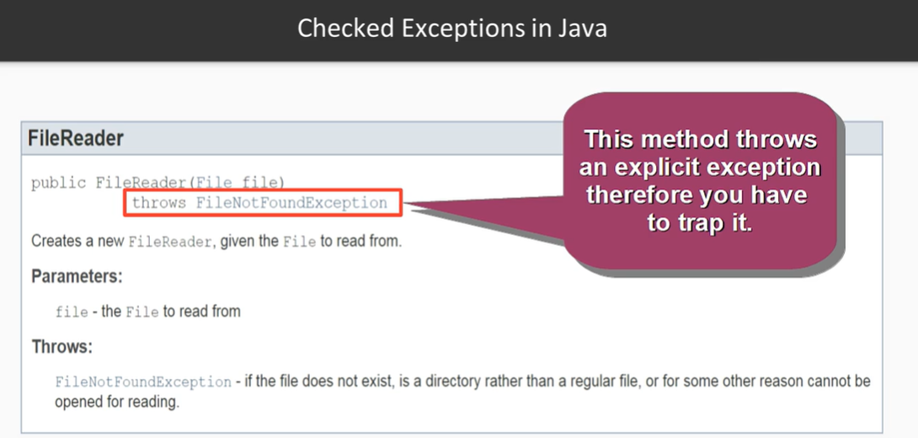

Rules When Applying an Exception Class

* Only methods may be involved in the exception process
* Each method must tell the runtime it is part of the exception handling process by advertising the fact by using the “throws” keyword
* Then the fault condition within the method must be identified; at that point, a new exception object must be thrown using the “throw” keyword

What is Debugging in Eclipse IDE?

* The routine process of locating and removing bugs, errors, or abnormalities from programs
* Eclipse has a very good built-in feature to help perform debugging tasks
* It means we are looking for logical errors for the most part – i.e. when you are expecting a certain value to be calculated and the result is not as expected

Two main different Perspective Window views:

* Java
* Debug

Java Perspective – this perspective is designed to support Java development. It offers Package Explorer, a Type Hierarchy, and Java-specific navigation actions

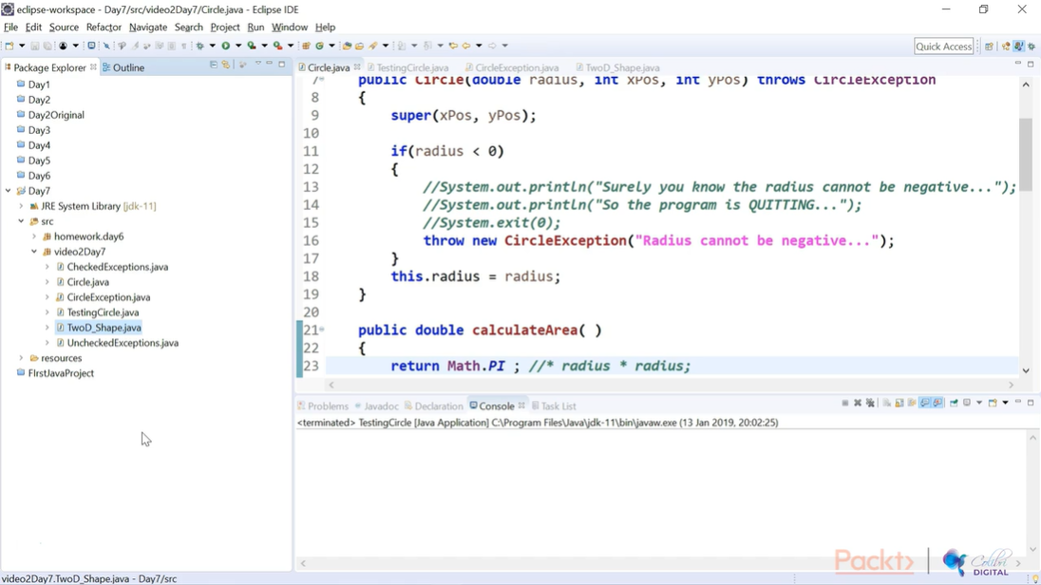

Debug Perspective – this perspective supports application debugging by providing views for displaying the bug stack, variables, and breakpoints

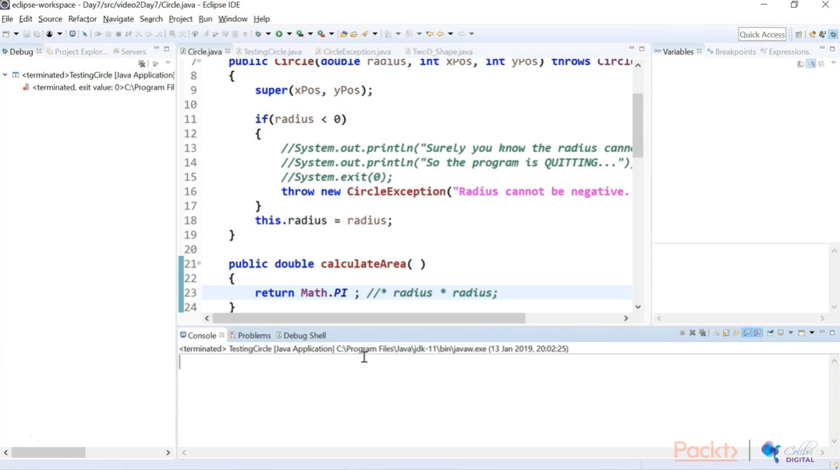

Day 7 Homework

